

|  |
| --- |
| Capstone Project User Manual |

|  |
| --- |
| **Rental House Finding System Team | FPT University** |
| **Hanoi, 28th Feb 2013** |

Table of Contents

1. Visitor 1

1.1. Search 1

1.2. Advanced Search 1

1.3. View Post Detail 2

1.4. Add Post 3

1.5. Edit Post 4

1.6. Delete Post 5

1.7. Renew Post 6

1.8. Register 7

2. User 7

2.1. Login 7

2.2. Logout 8

2.3. Edit user profile 8

2.4. Change password 10

2.5. Recover password 10

2.6. View favorite list 11

2.7. Add favorite 11

2.8. Remove favorite 12

2.9. Compare 13

2.10. Manage post 15

2.11. Manage payment 15

3. Administrator 16

3.1. Manage posts 16

3.2. Manage payments 16

3.3. Manage post categories 17

3.3.1. View categories list 17

3.3.2. Create new category 17

3.3.2. Edit category 18

3.4. Manage user roles 19

3.4.1. View roles list 19

3.4.2. Create new role 19

3.4.3. Edit role 20

3.5. Manage provinces 20

3.5.1. View provinces list 20

3.5.2. Add new province 21

3.5.3. Edit province 21

3.6. Manage districts 22

3.6.1. View districts list 22

3.6.2. Add new district 22

3.6.3. Edit district 23

3.7. Manage locations 23

3.7.1. View locations list 23

3.7.2. Add new location 24

3.7.3. Edit location 24

3.8. Manage bad words 25

3.8.1. View bad words list 25

3.8.2. Add new bad word 26

3.8.3. Edit bad word 26

3.9. Manage bad word categories 27

3.9.1. View bad word categories list 27

3.9.2. Add new bad word category 27

3.9.3. Edit bad word category 27

3.10. Manage bad posts 28

3.11. Manage reported posts 28

3.12. Manage post statuses 29

3.12.1. View post statuses list 29

3.12.2. Add new post status 29

3.12.3. Edit post status 30

3.13. Manage config score 31

3.13.1. View score list 31

3.13.2. Edit score value 31

3.13.3. Add new score 31

## Visitor

### Search

* + - Navigate to homepage
    - Select type of house, province, and district where you want to search
    - Enter additional keyword
    - Click search, or hit Enter

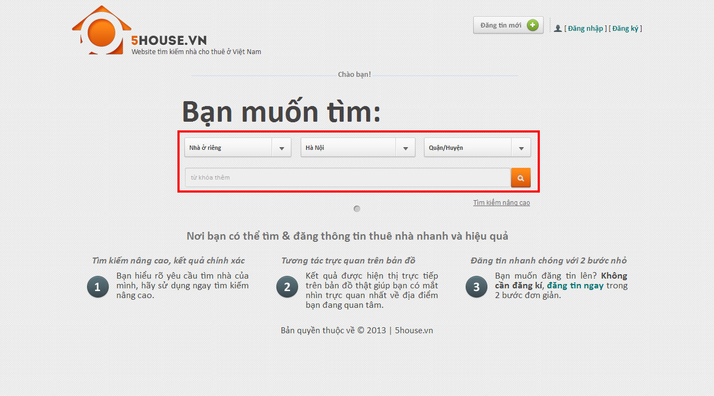

## Advanced Search

* + - Navigate to homepage
    - Click “Tìm kiếm nâng cao”
    - Select type of house, province, and district where you want to search
    - Provide desired price range and area range (not required)
    - Provide information concerning facilities priorities. There are 3 values of priority: Thấp, Vừa, Cao. Unpicked facilities will be ignored.

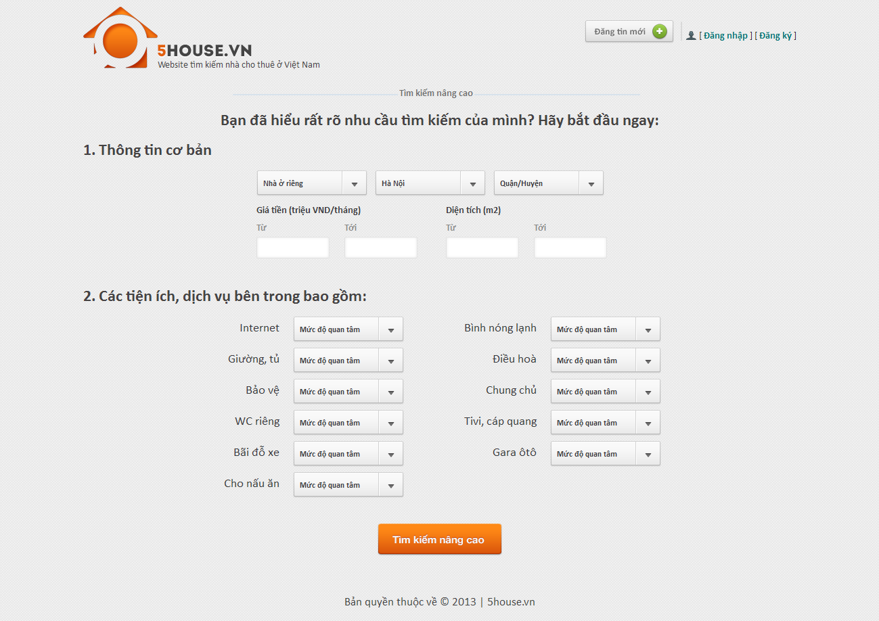

## View Post Detail

* + - Perform a search then click on a result on the list or a marker on the map, or enter the link directly to browser’s address bar

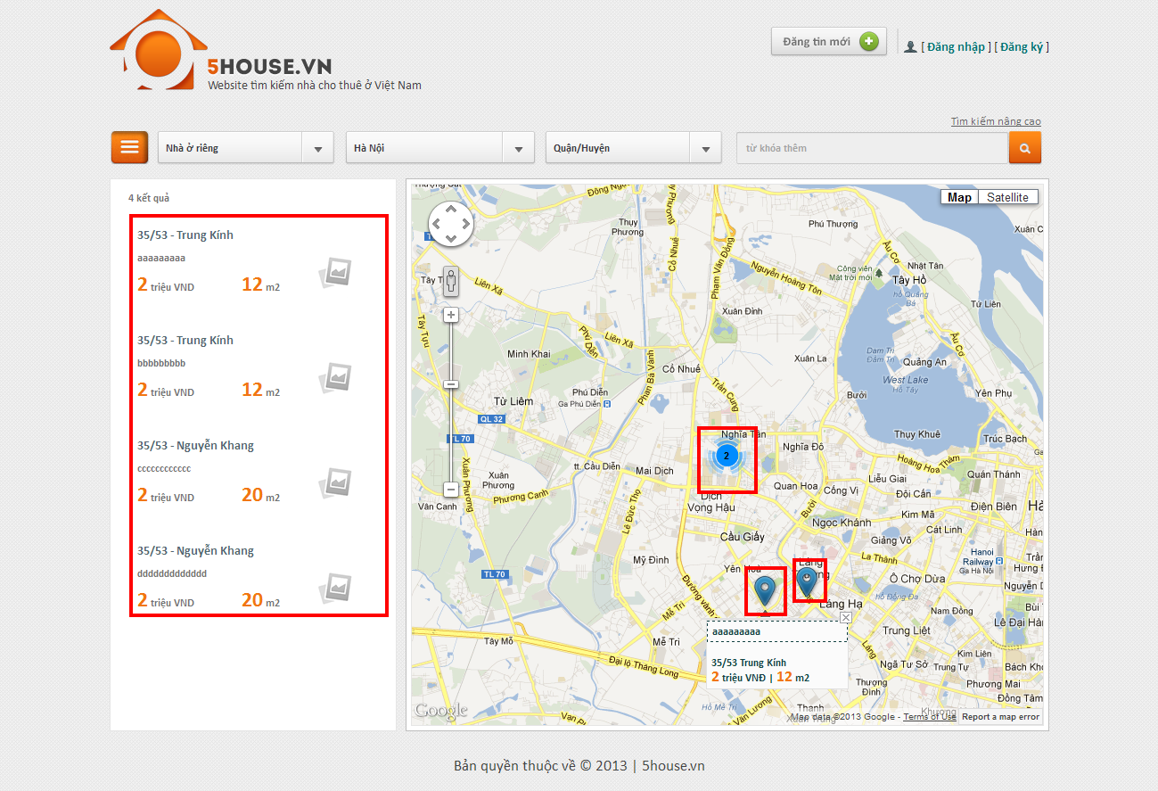

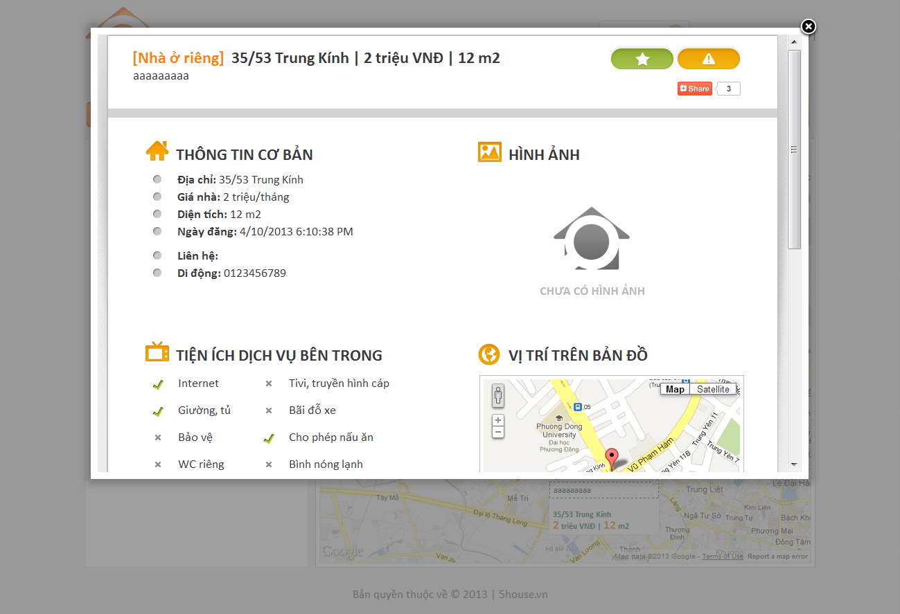

## Add Post

* + - Click on “Đăng tin mới” button on top of any page
    - Enter input as prompted

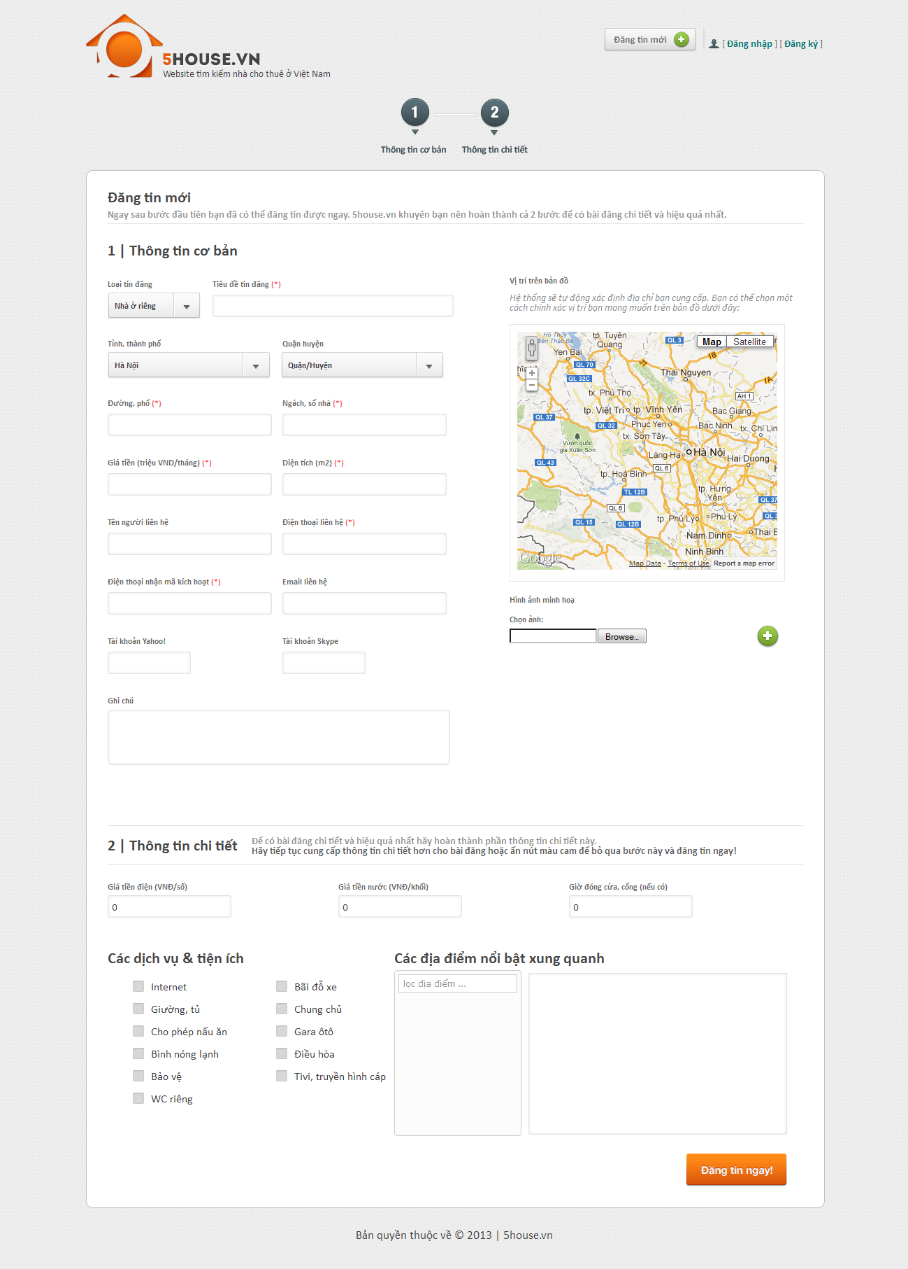

## Edit Post

* + - Enter the link provided when posting into the browser
    - Enter the provided password
    - Edit post details
    - Click “Lưu thay đổi” button

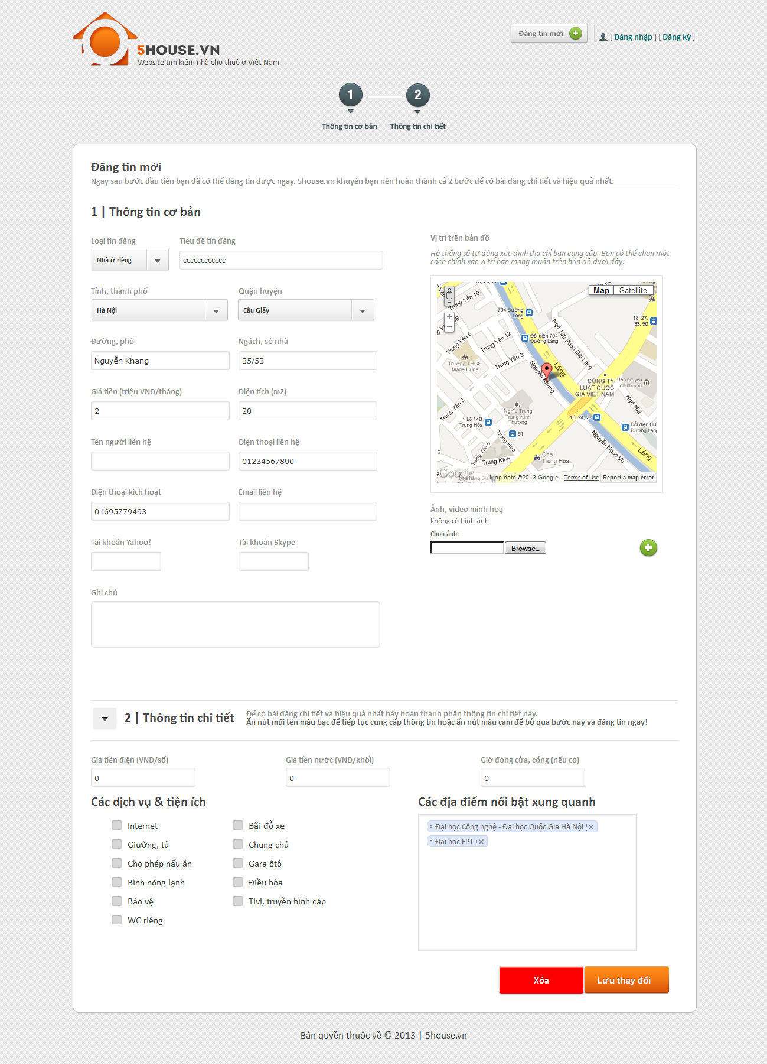

## Delete Post

* + - Enter the link provided when posting into the browser
    - Enter the provided password
    - Edit post details
    - Click “Xóa” button



## Renew Post

* + - Send and SMS with the following content to our SMS service
      * MS [password]

With [password] is the one that was provided when posting.

## Register

* + - Click on “Đăng ký” link
    - Provide details as prompted
    - Click “Đăng ký” button

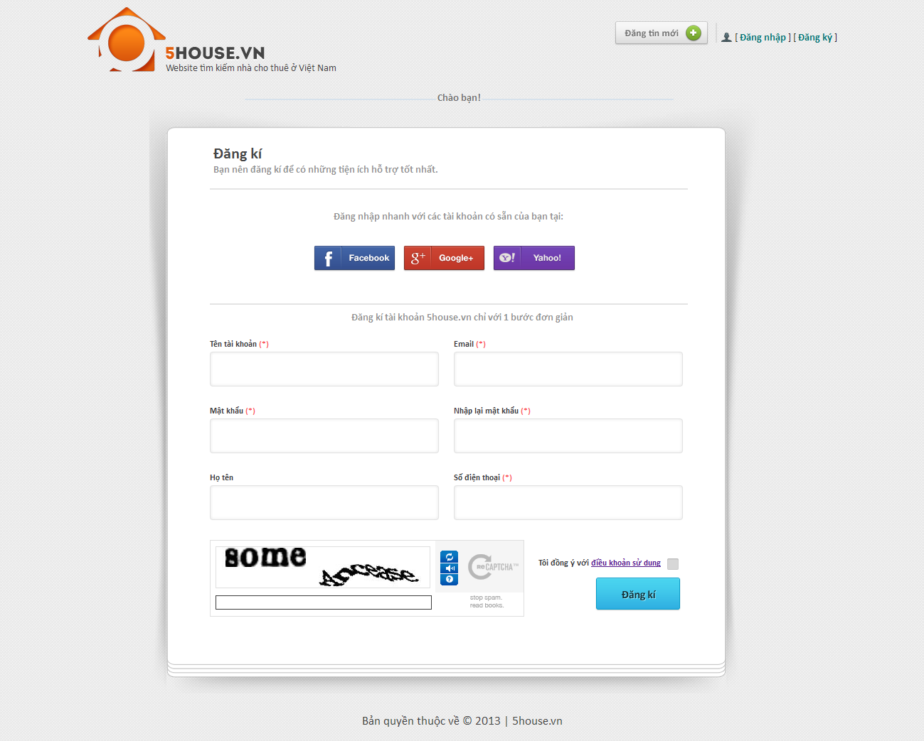

## User

## Login

* + - Click on “Đăng nhập” button
    - Login with registered username and password, or use Facebook/Google/Yahoo ID

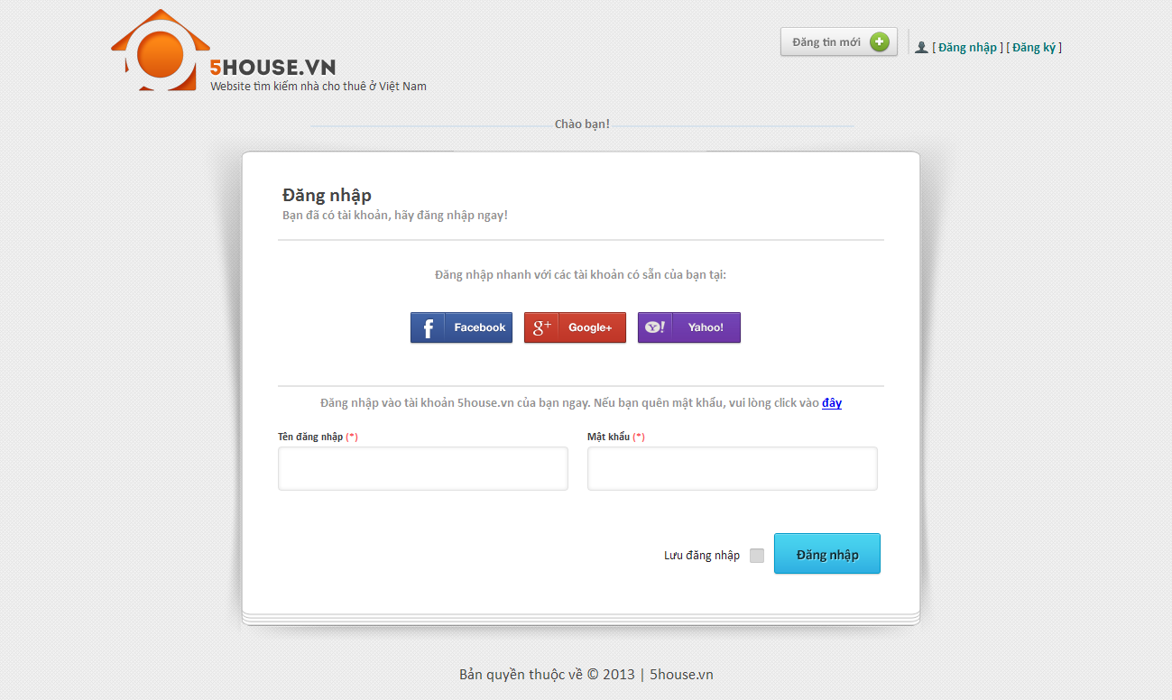

## Logout

* + - User must have logged into the system
    - Click on “Thoát” button

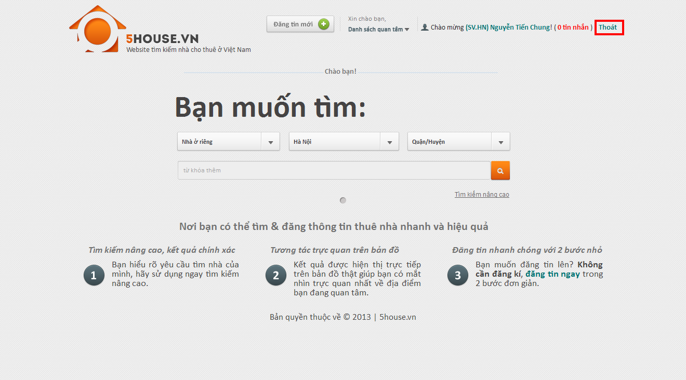

## Edit user profile

* + - Login to the system
    - Go to User Control Panel by clicking on the displayed username on top of the page
    - Click “Thay đổi thong tin” button
    - Edit user details
    - Click “Lưu thay đổi” button

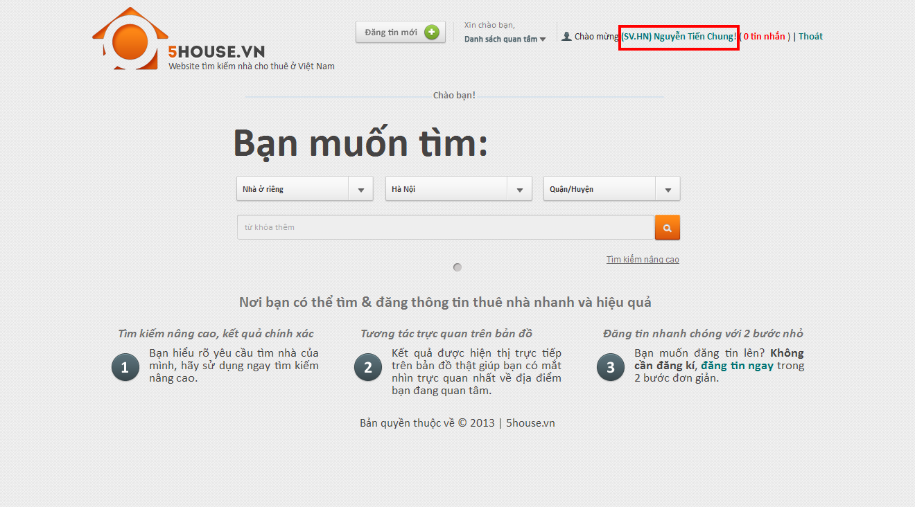

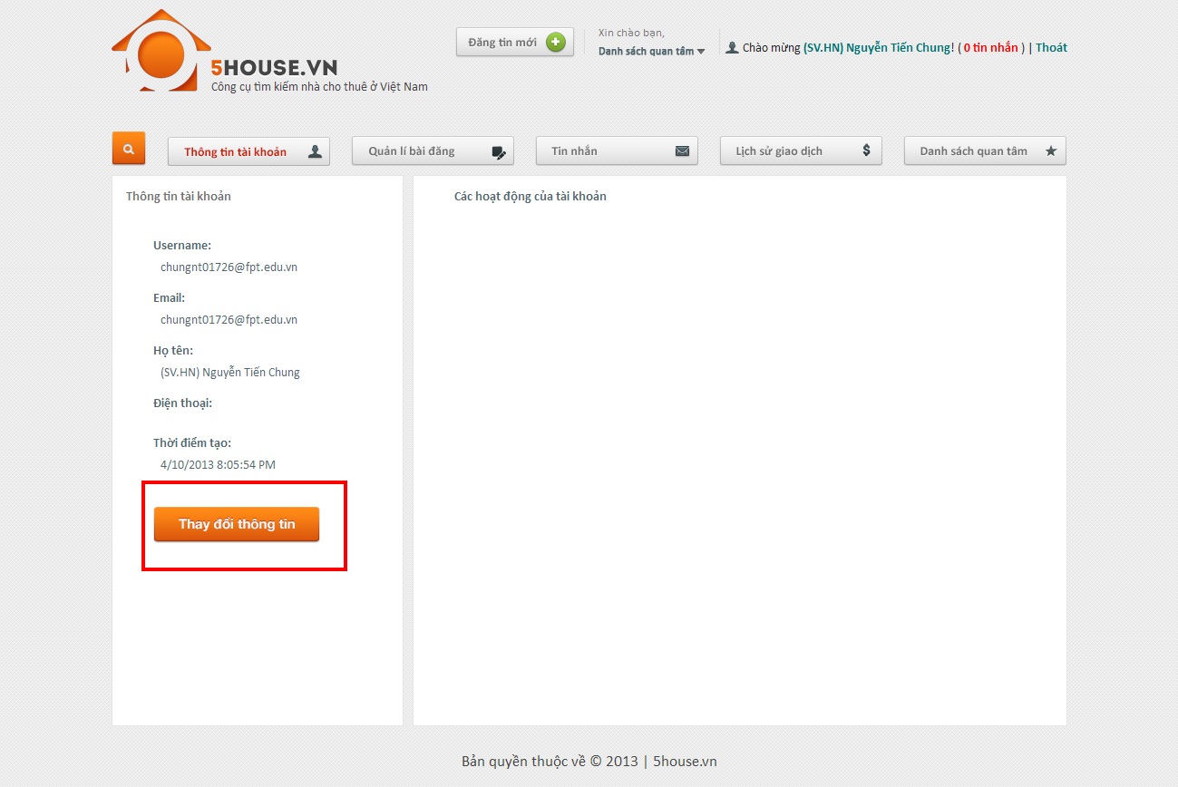

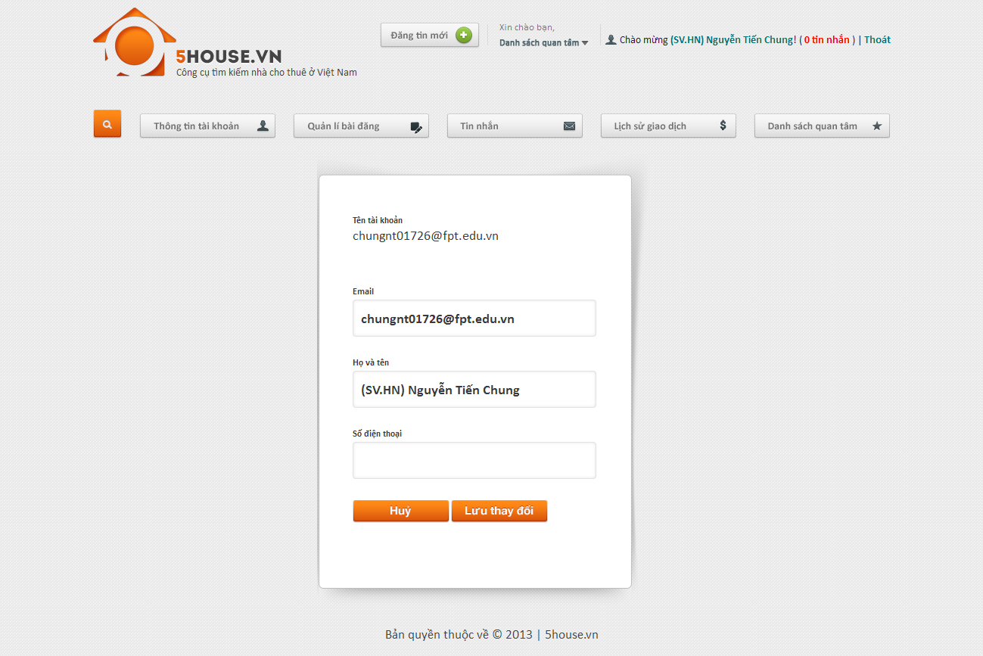

## Change password

* + - Login to the system
    - Go to User Control Panel
    - Click on “Đổi mật khẩu” button
    - Provide new password
    - Click “Lưu thay đổi”

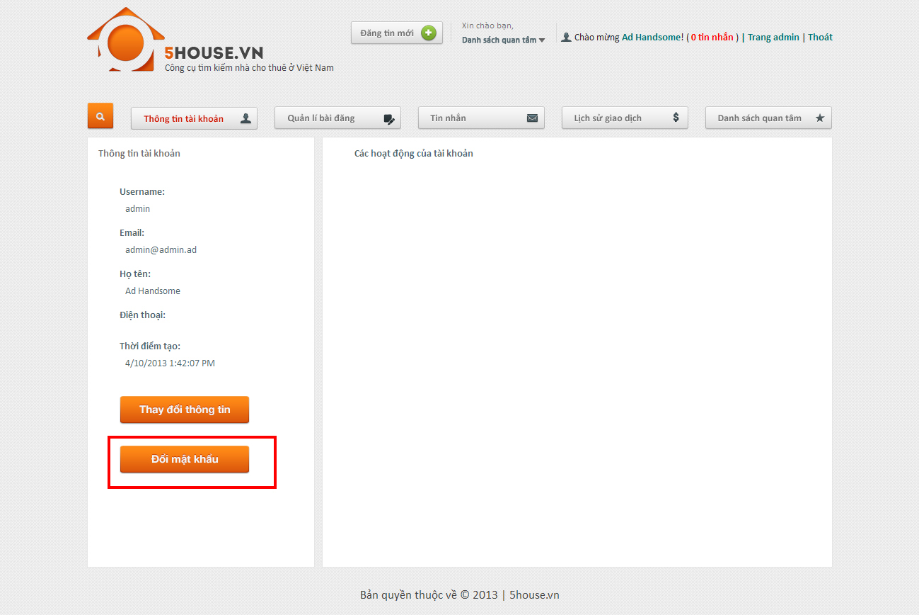

## Recover password

* + - Go to login page
    - Click on password recovery link
    - Click button

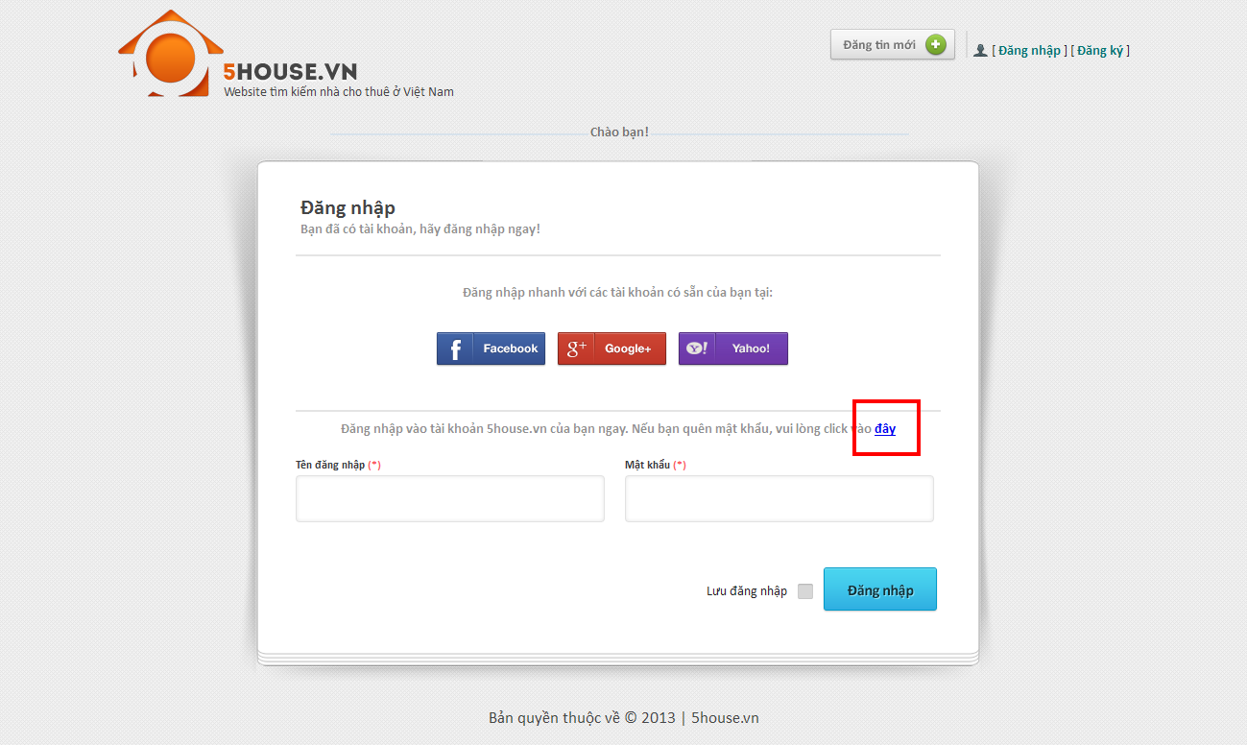

## View favorite list

* + - Go to User Control Panel
    - Click on “Quản lý bài đăng” button

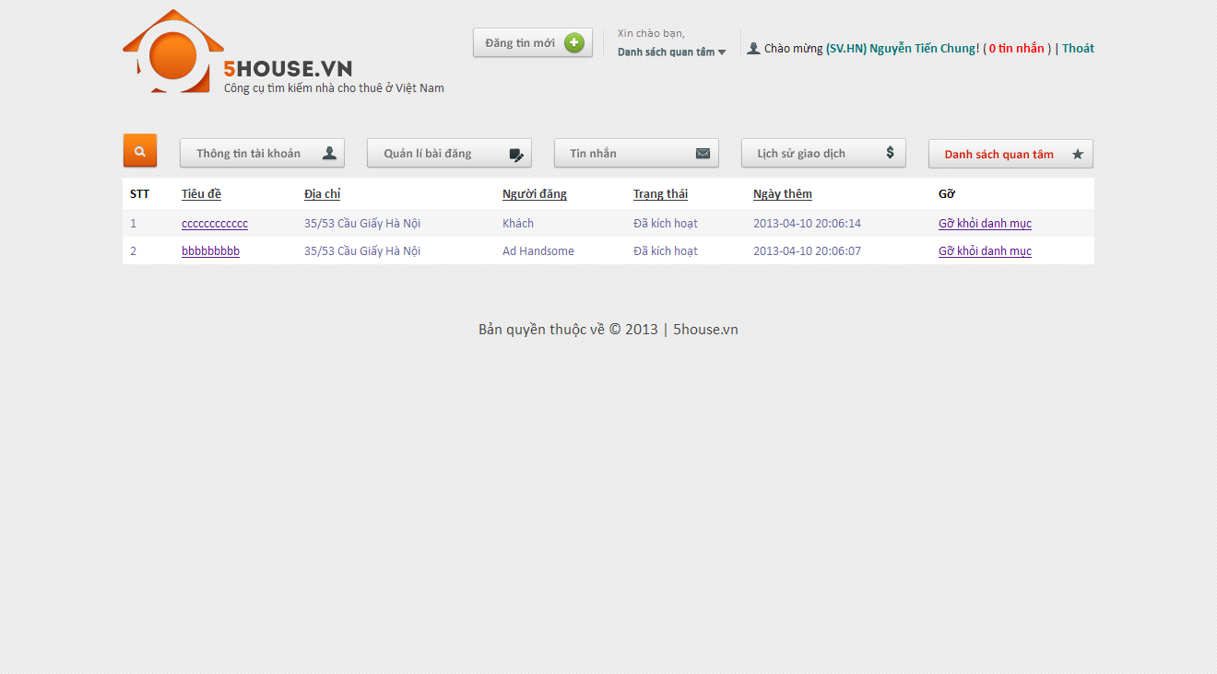

## Add favorite

* + - View a post which is not in favorite list
    - Click on Favorite button

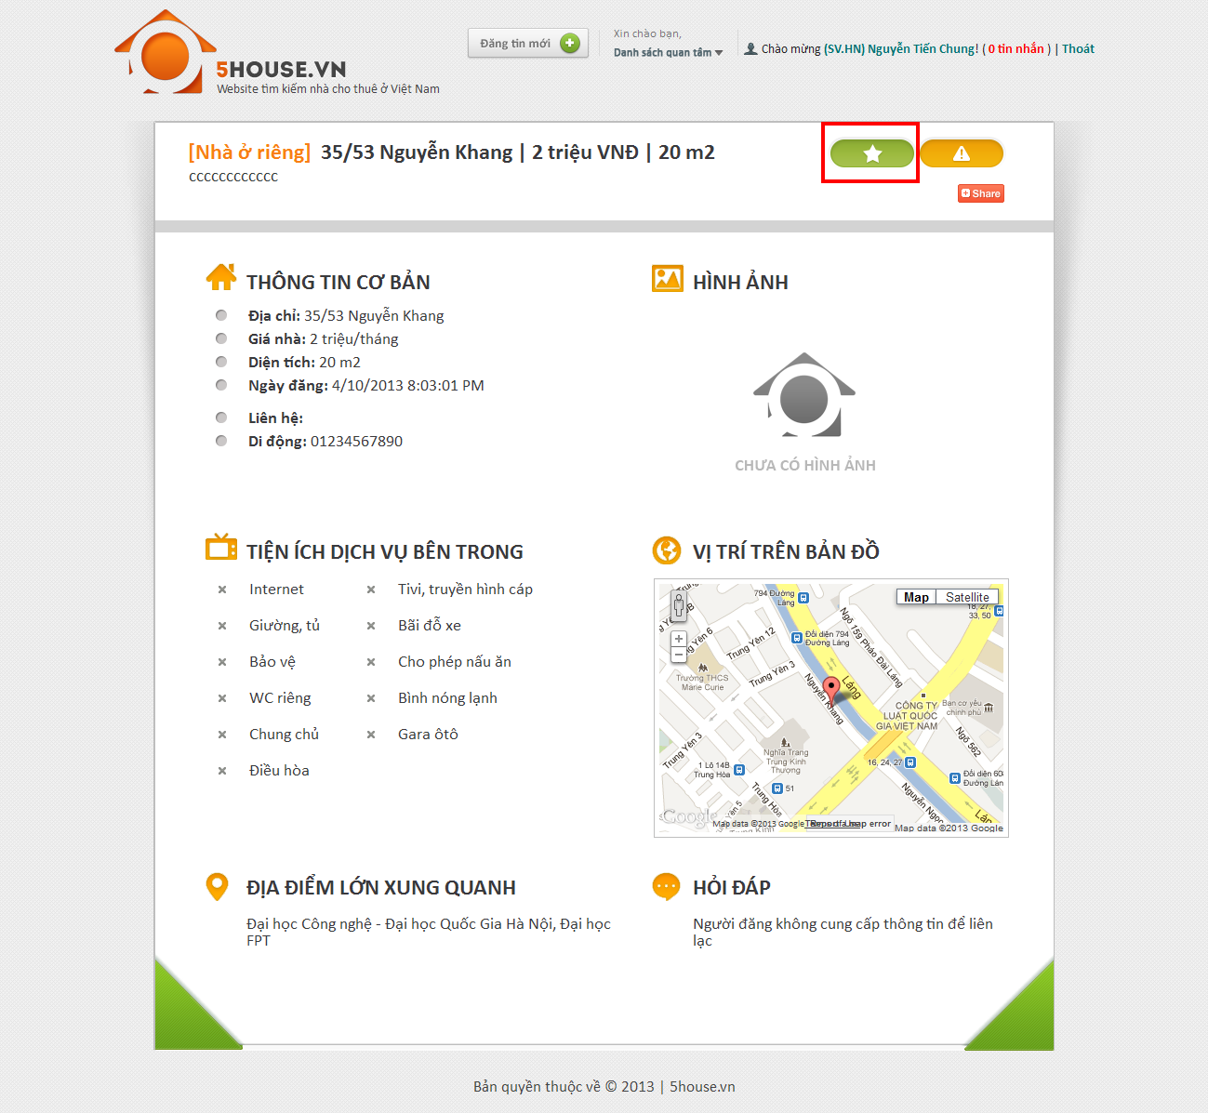

## Remove favorite

* + - View a post which is currently in favorite list
    - Click on Favorite button

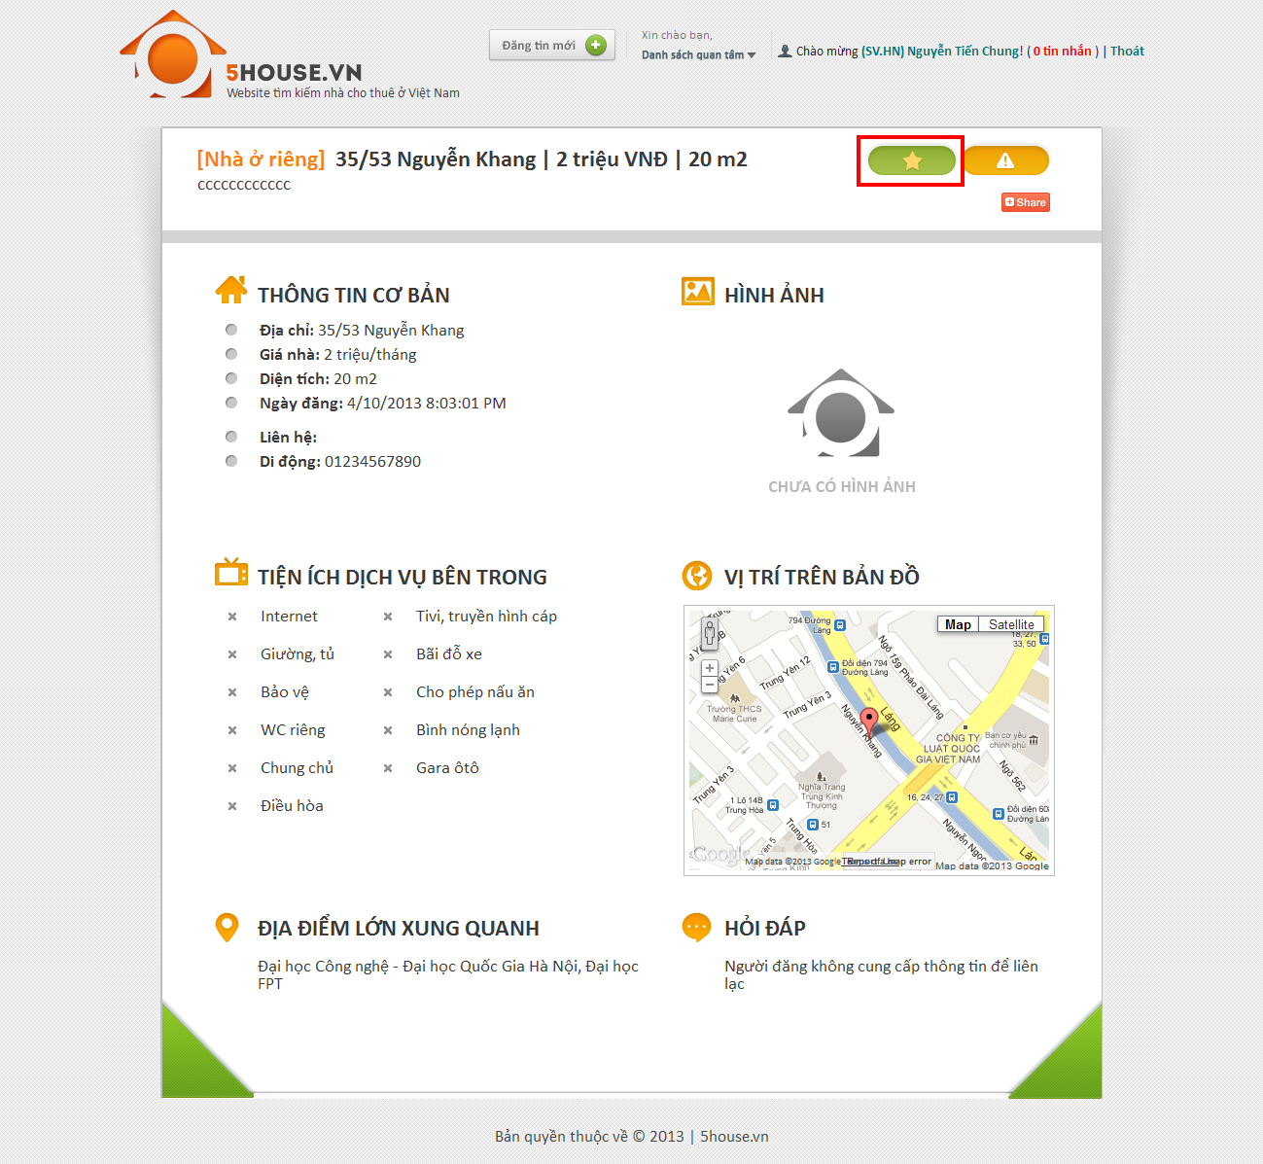

## Compare

* + - Add at least 2 post to favorite list
    - Click on “Danh sách quan tâm” link
    - Check at least 2 post
    - Click “So sánh”

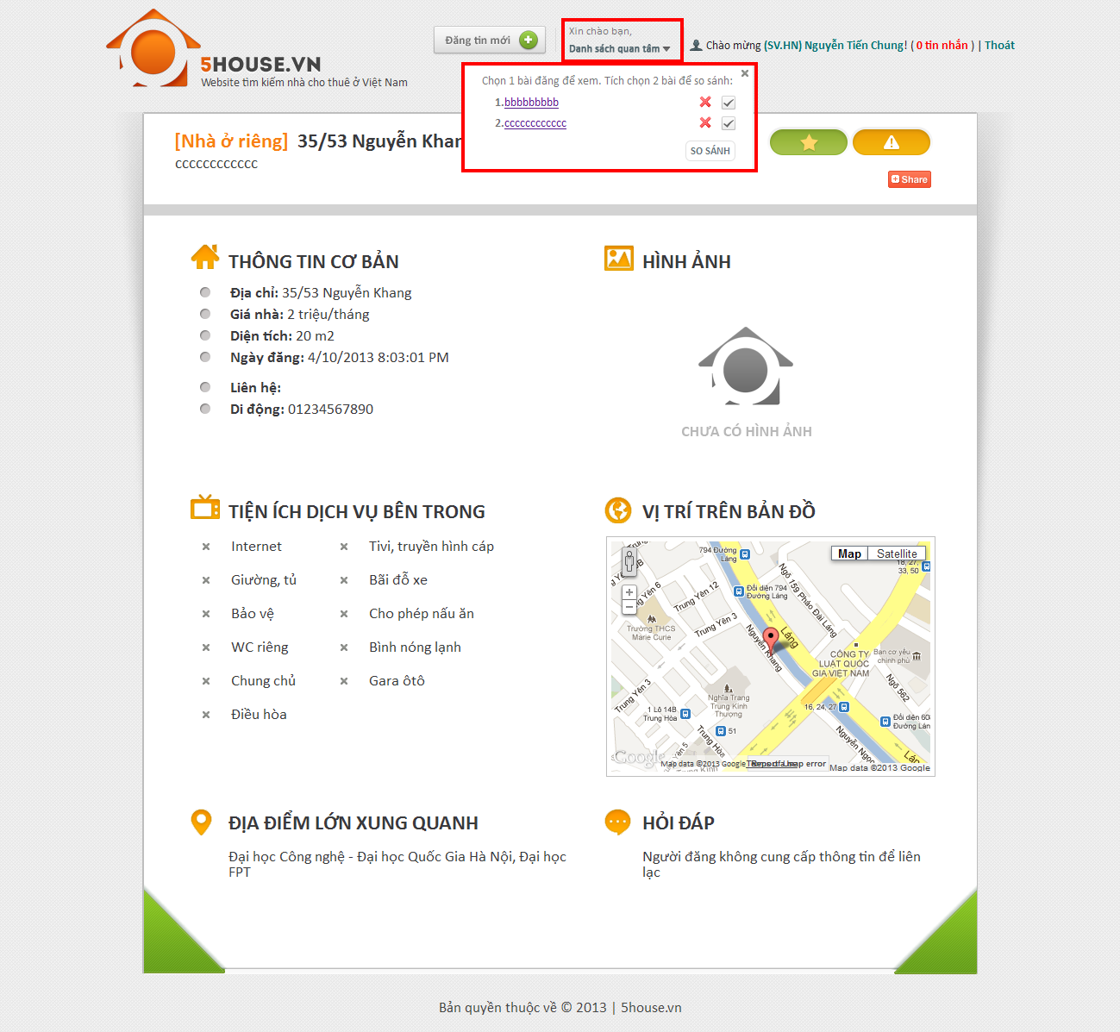

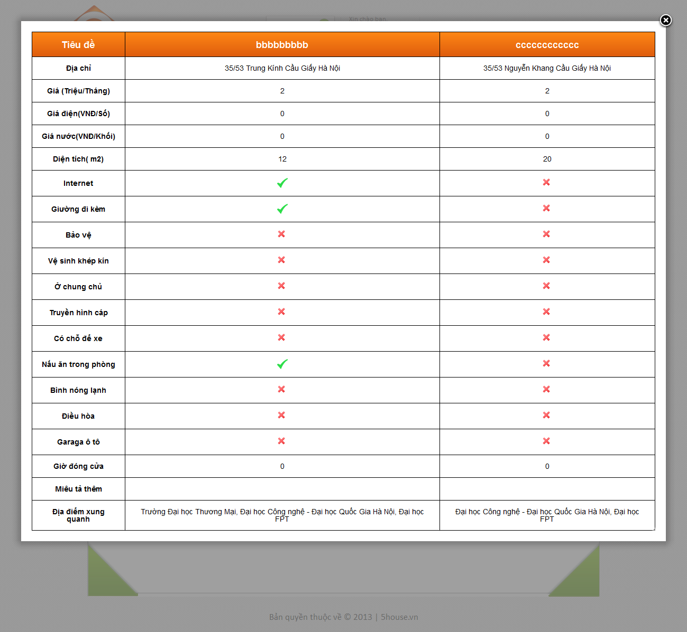

## Manage post

* + - Go to User Control Panel
    - Click on “Quản lý bài đăng” button

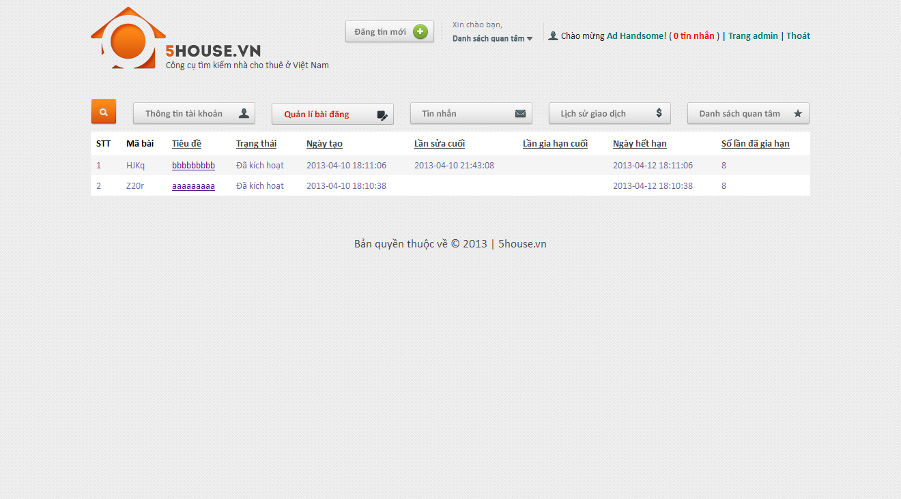

## Manage payment

* + - Go to User Control Panel
    - Click on “Lịch sử giao dịch” button

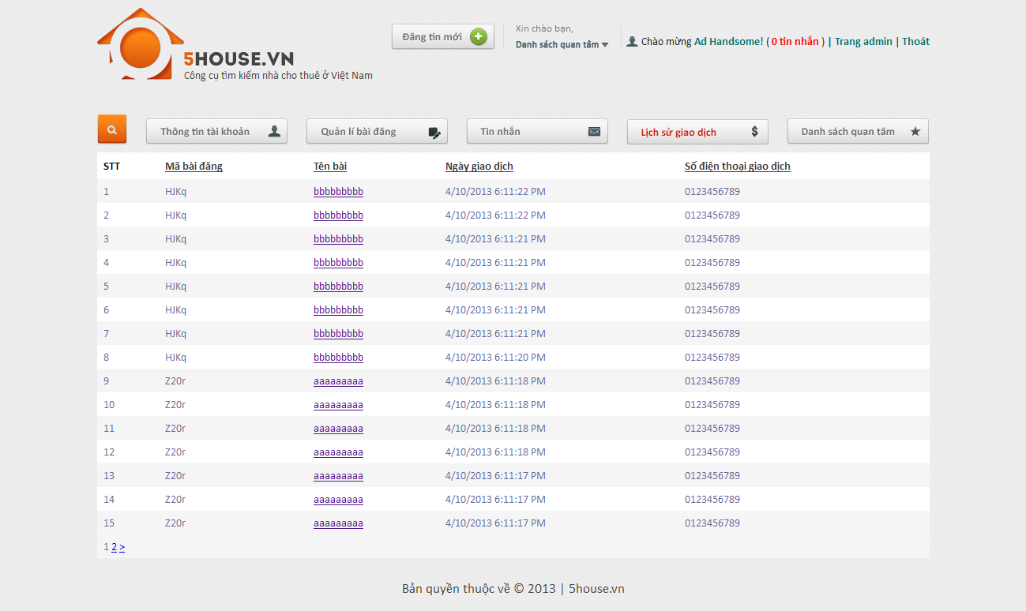

## Administrator

## Manage posts

* + - Login to the system as admin
    - Go to Admin Management page
    - Click on “Bài đăng” tab

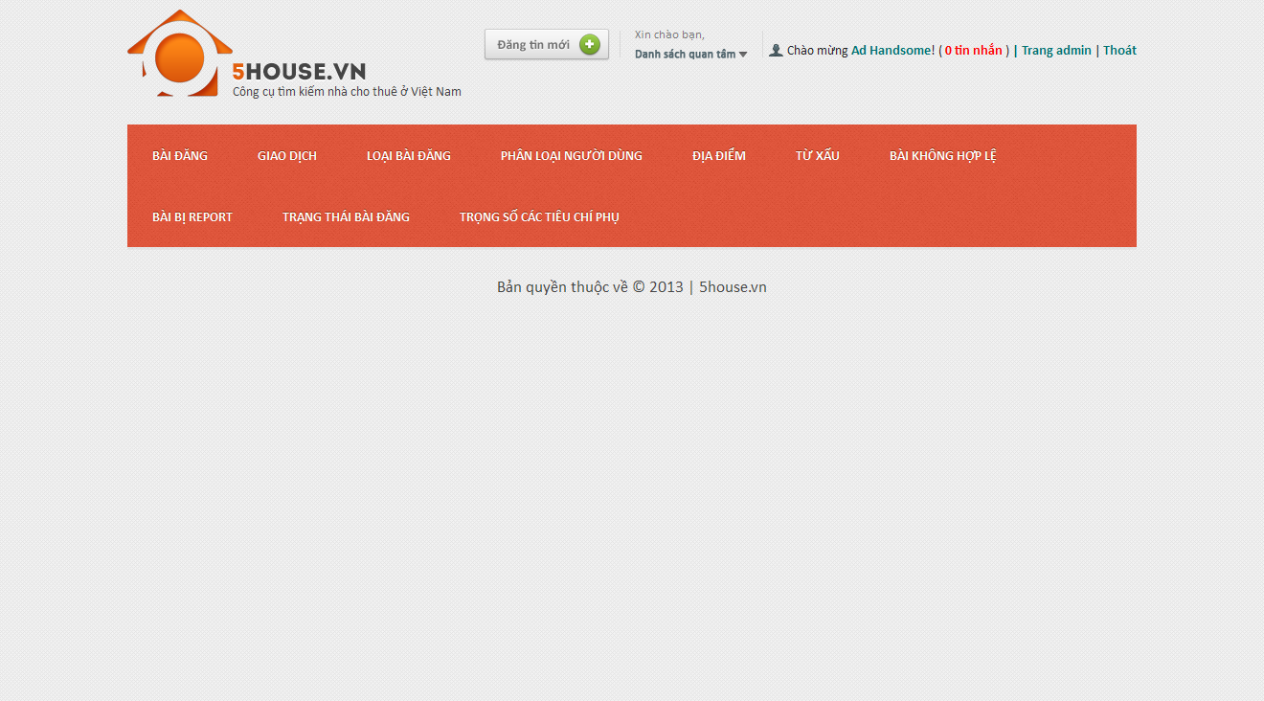

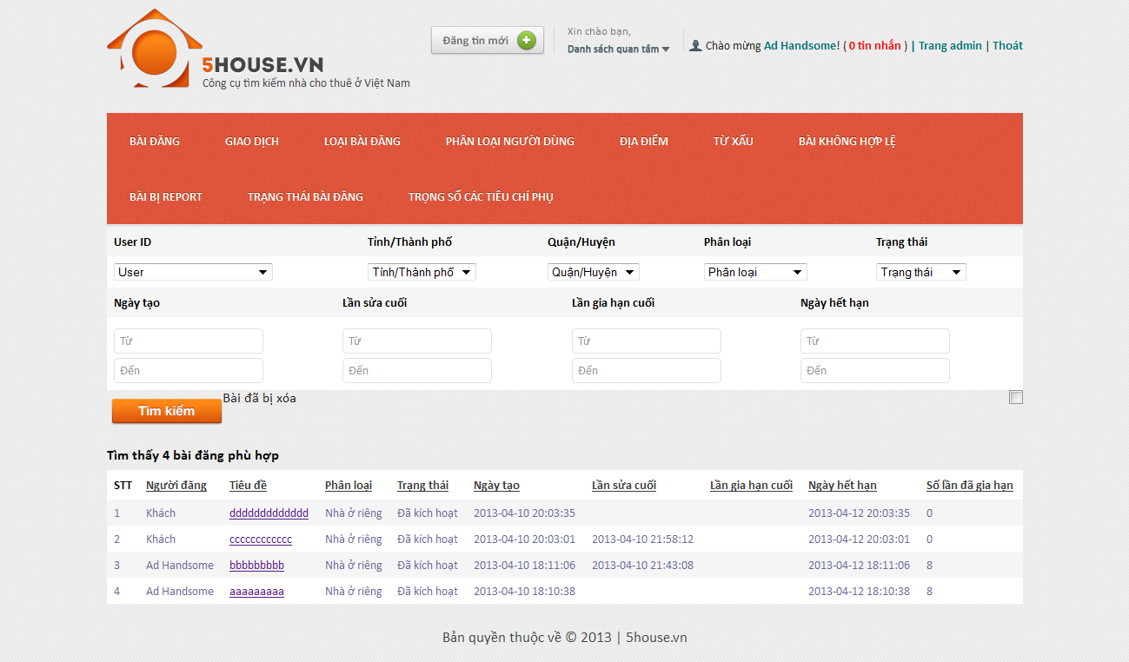

## Manage payments

* + - Login to the system as admin
    - Go to Admin Management page
    - Click on “Giao dịch” tab

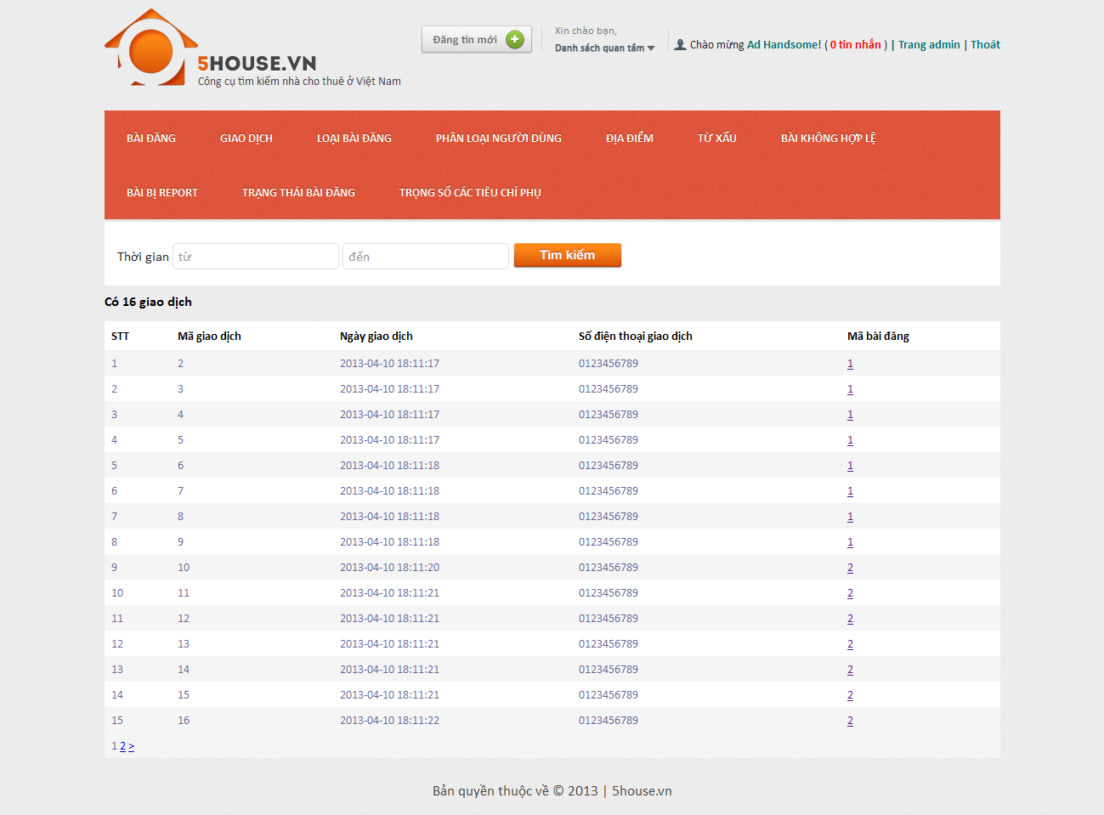

## Manage post categories

## View categories list

* + - * Login to the system as admin
      * Go to Admin Management page
      * Click on “Loại bài đăng” tab

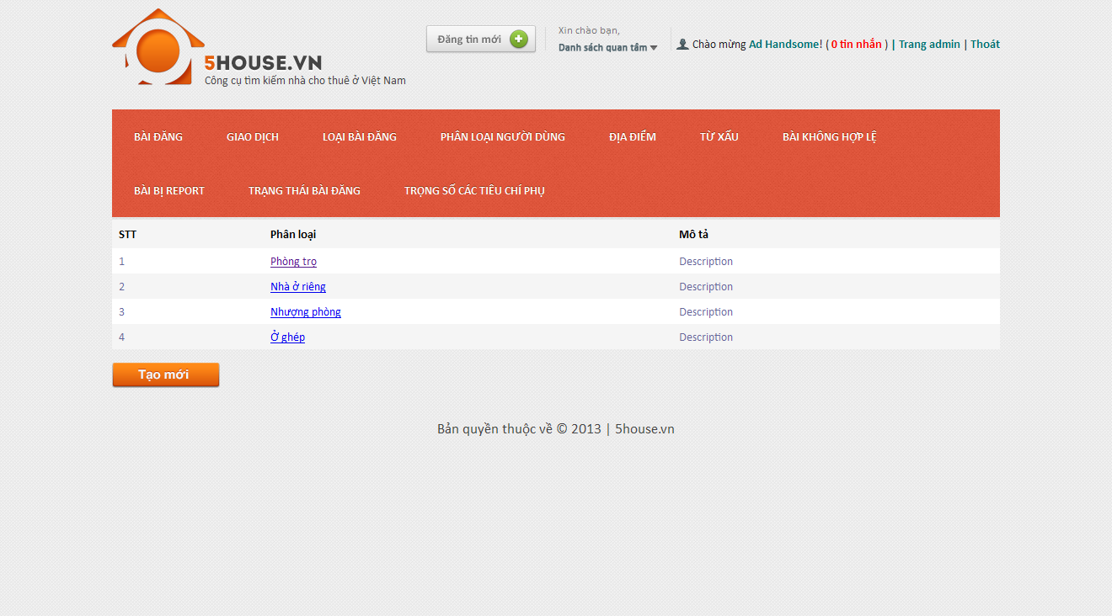

## Create new category

* + - * Login to the system as admin
      * Go to Admin Management page
      * Click on “Loại bài đăng” tab
      * Click on “Tạo mới” button
      * Enter details as prompted
      * Click on “Tạo mới” button

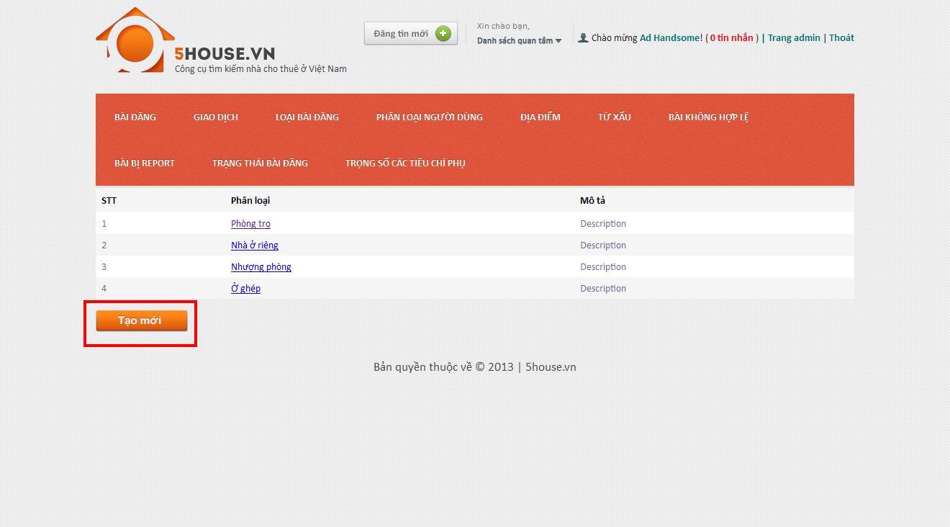

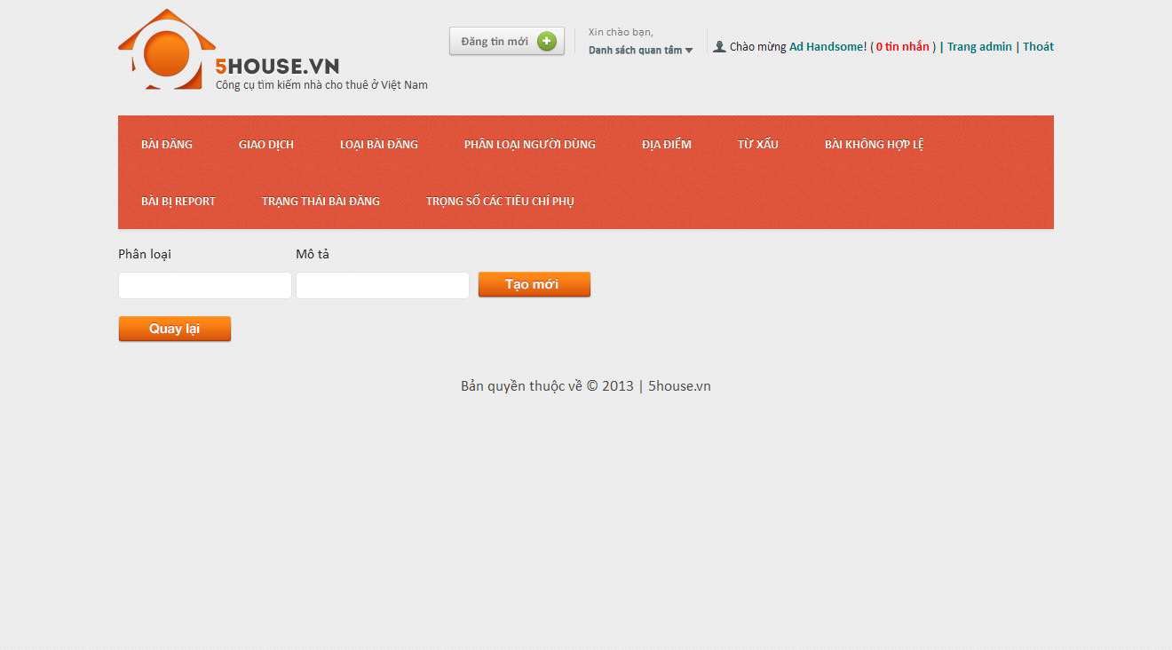

## Edit category

* + - * Login to the system as admin
      * Go to Admin Management page
      * Click on “Loại bài đăng” tab
      * Click on an item on the table
      * Modify details
      * Click on “Lưu thay đổi” button

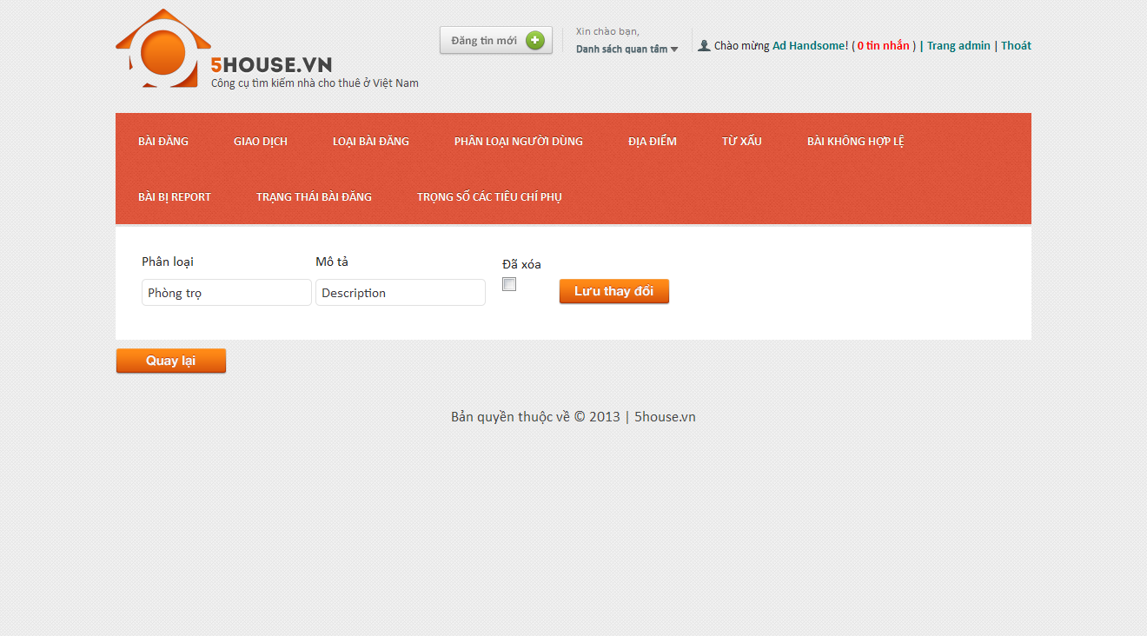

## Manage user roles

## View roles list

* + - * Login to the system as admin
      * Go to Admin Management page
      * Click on “Phân loại người dùng” tab

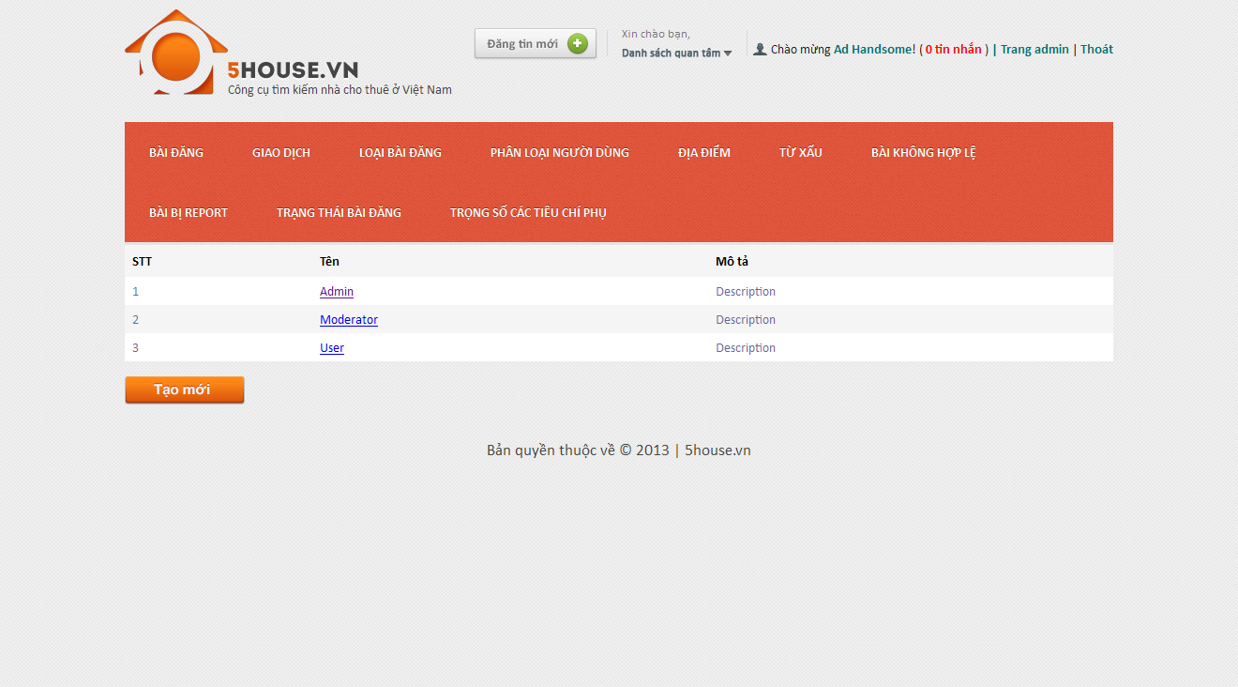

## Create new role

* + - * Login to the system as admin
      * Go to Admin Management page
      * Click on “Phân loại người dùng” tab
      * Click “Tạo mới” button

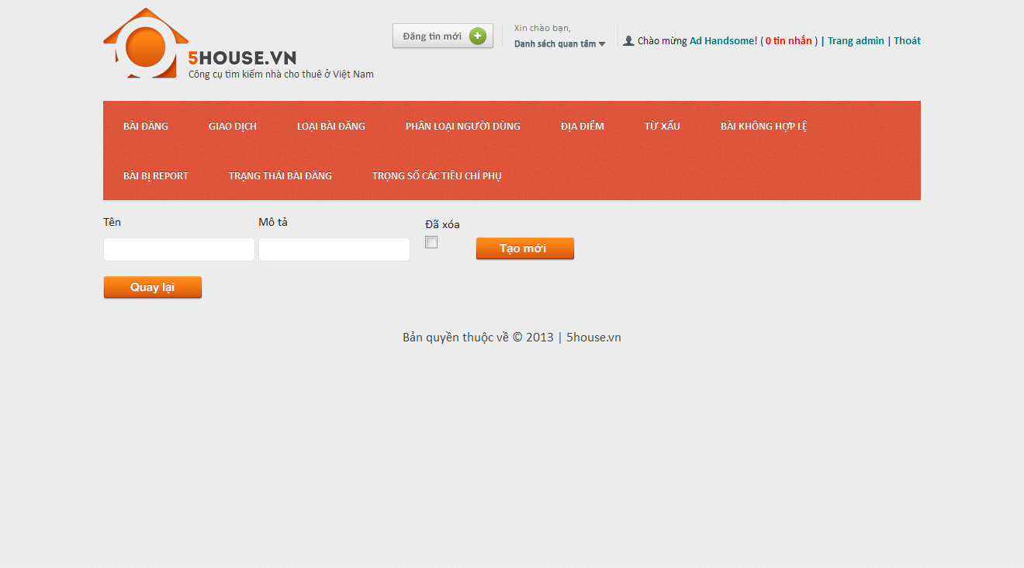

## Edit role

* + - * Login to the system as admin
      * Go to Admin Management page
      * Click on “Phân loại người dùng” tab
      * Click on an item on the table
      * Modify details
      * Click on “Lưu thay đổi” button

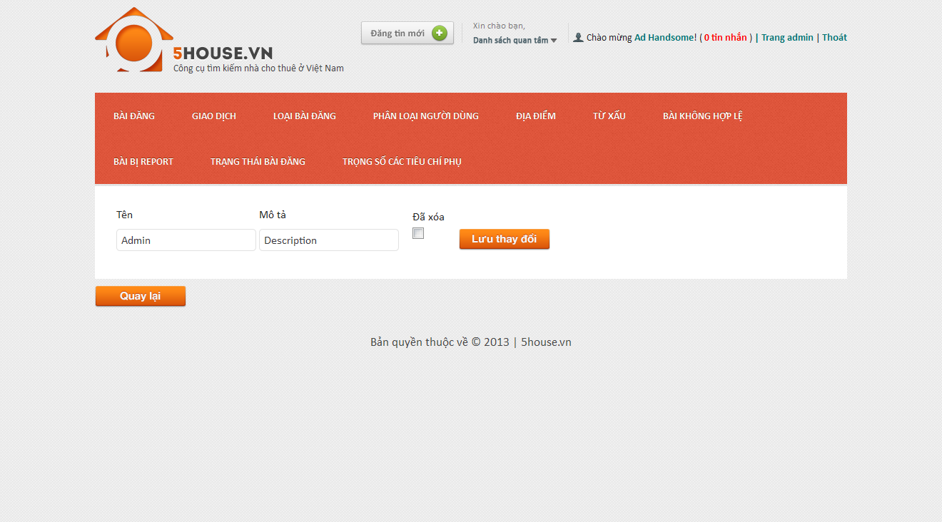

## Manage provinces

## View provinces list

* + - * Login to the system as admin
      * Go to Admin Management page
      * Point on “Địa điểm”
      * Click on “Tỉnh/Thành” tab

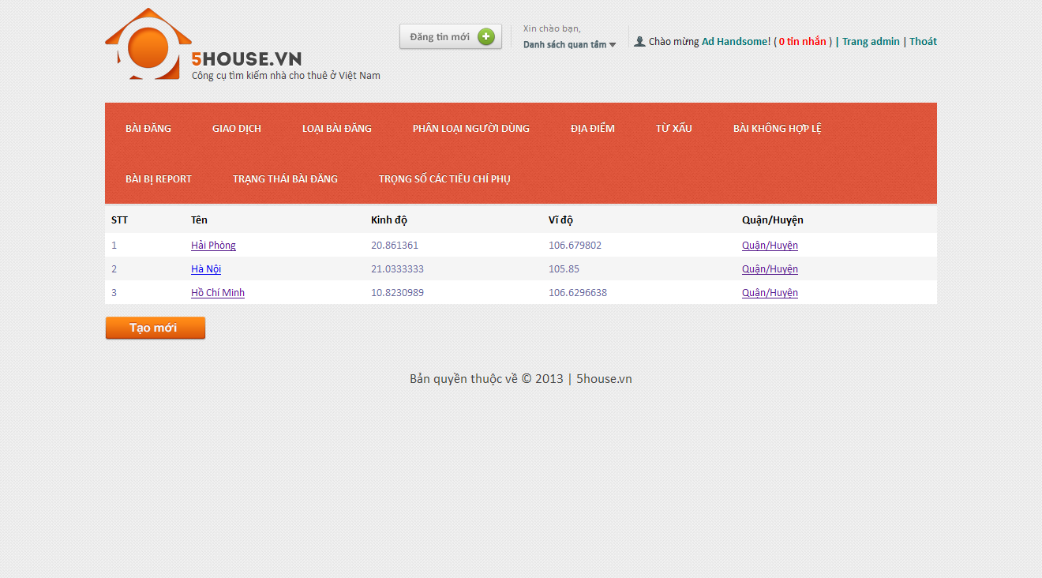

## Add new province

* + - * Login to the system as admin
      * Go to Admin Management page
      * Point on “Địa điểm”
      * Click on “Tỉnh/Thành” tab
      * Click “Tạo mới” button

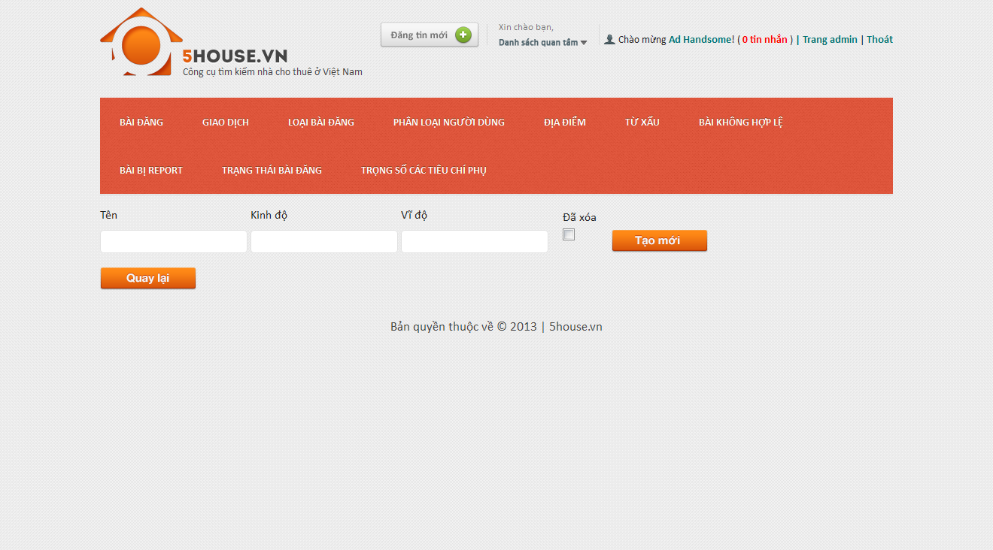

## Edit province

* + - * Login to the system as admin
      * Go to Admin Management page
      * Point on “Địa điểm”
      * Click on “Tỉnh/Thành” tab
      * Click on an item on the table
      * Modify details
      * Click on “Lưu thay đổi” button

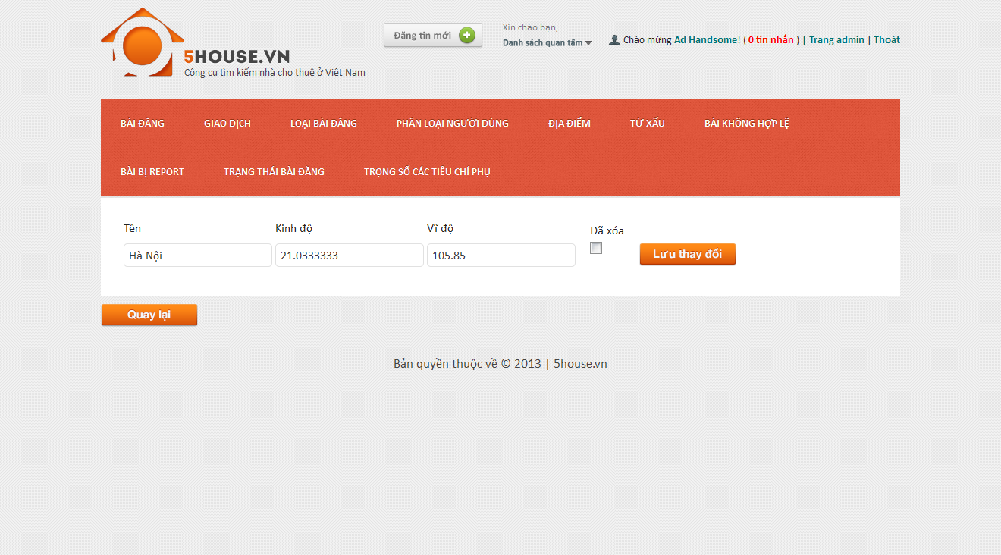

## Manage districts

## View districts list

* + - * Login to the system as admin
      * Go to Admin Management page
      * Point on “Địa điểm”
      * Click on “Quận/Huyện” tab

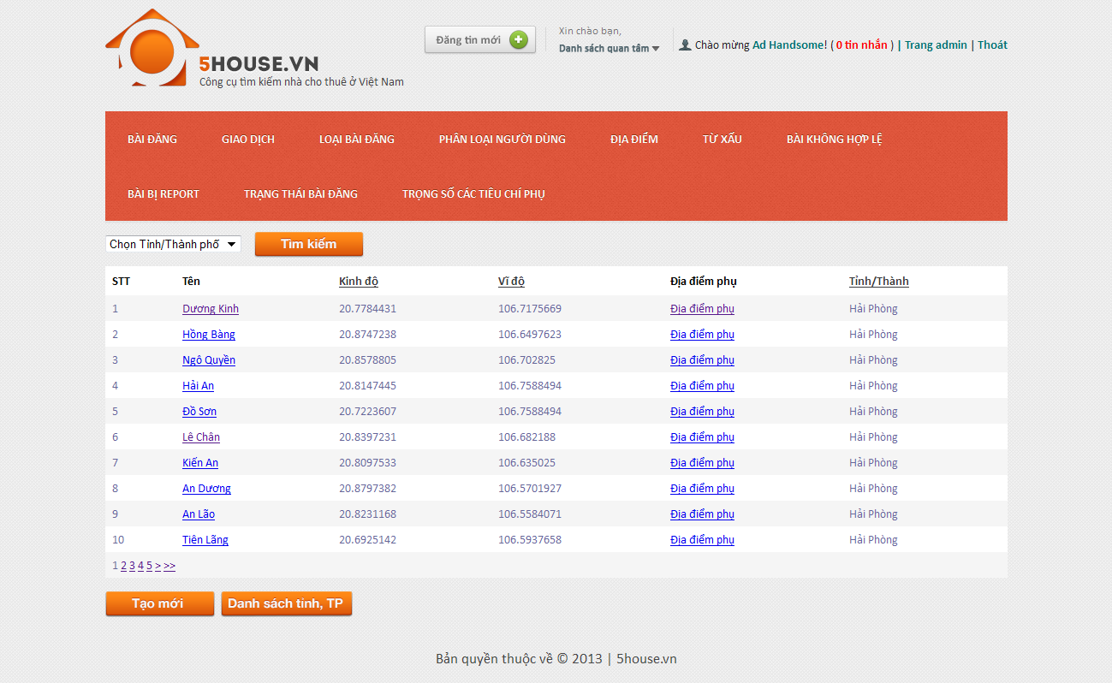

## Add new district

* + - * Login to the system as admin
      * Go to Admin Management page
      * Point on “Địa điểm”
      * Click on “Quận/Huyện” tab
      * Click “Tạo mới” button

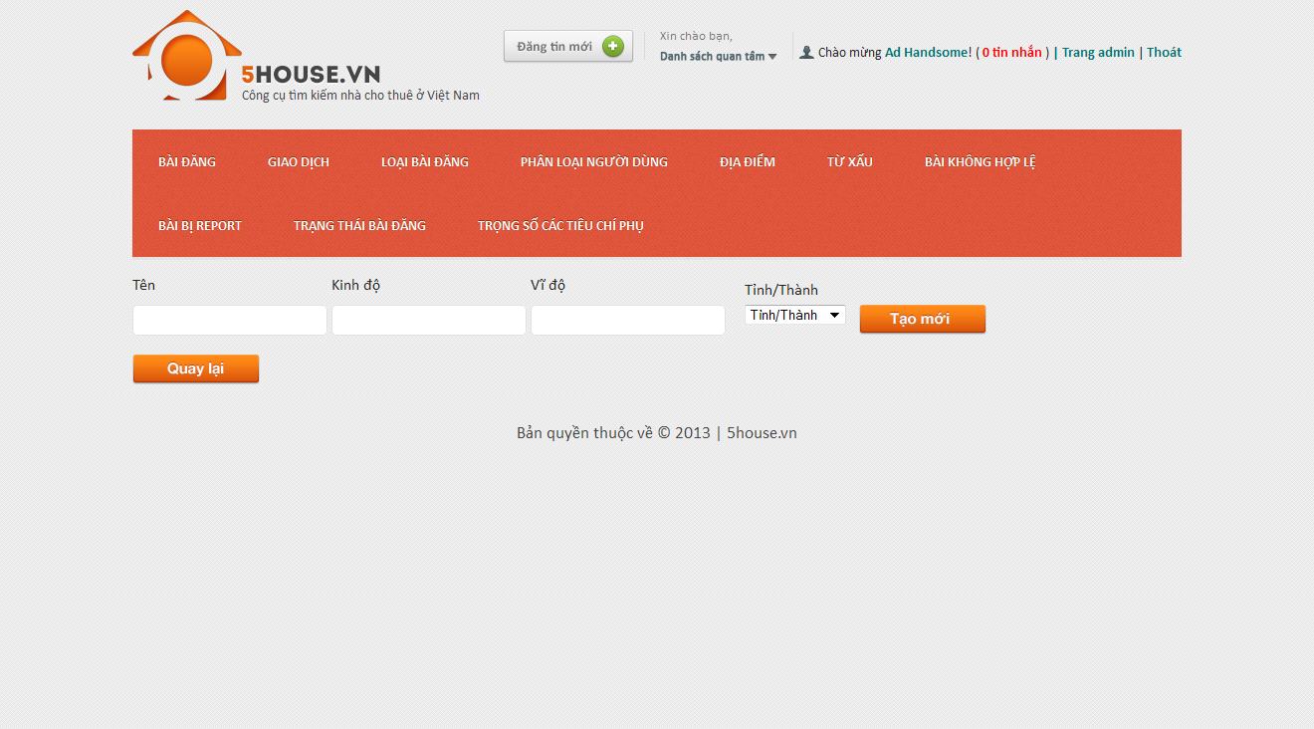

## Edit district

* + - * Login to the system as admin
      * Go to Admin Management page
      * Point on “Địa điểm”
      * Click on “Quận/Huyện” tab
      * Click on an item on the table
      * Modify details
      * Click on “Lưu thay đổi” button

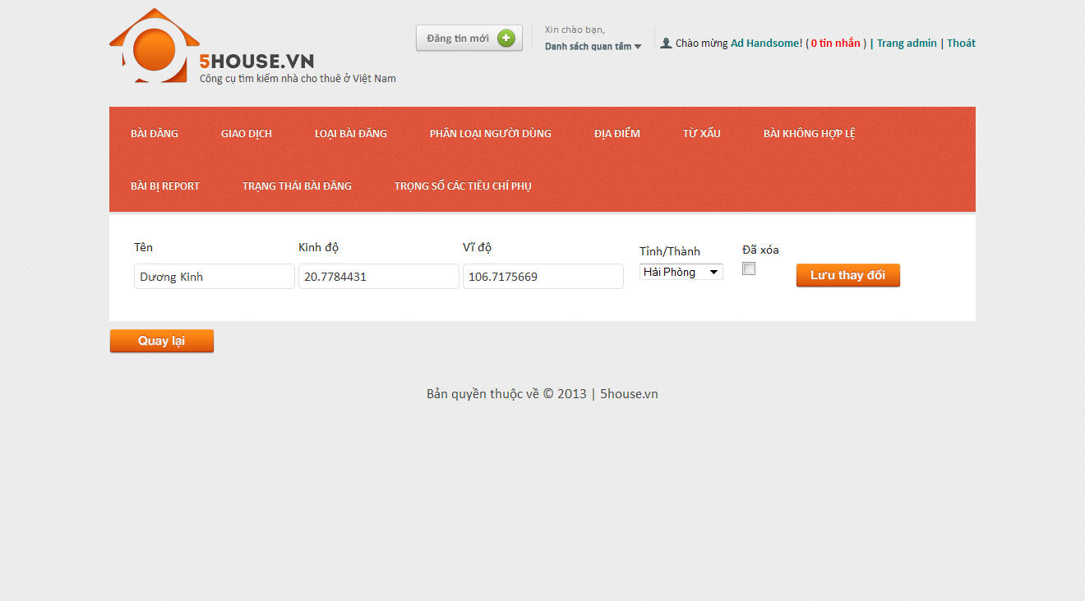

## Manage locations

## View locations list

* + - * Login to the system as admin
      * Go to Admin Management page
      * Point on “Địa điểm”
      * Click on “Địa điểm phụ” tab

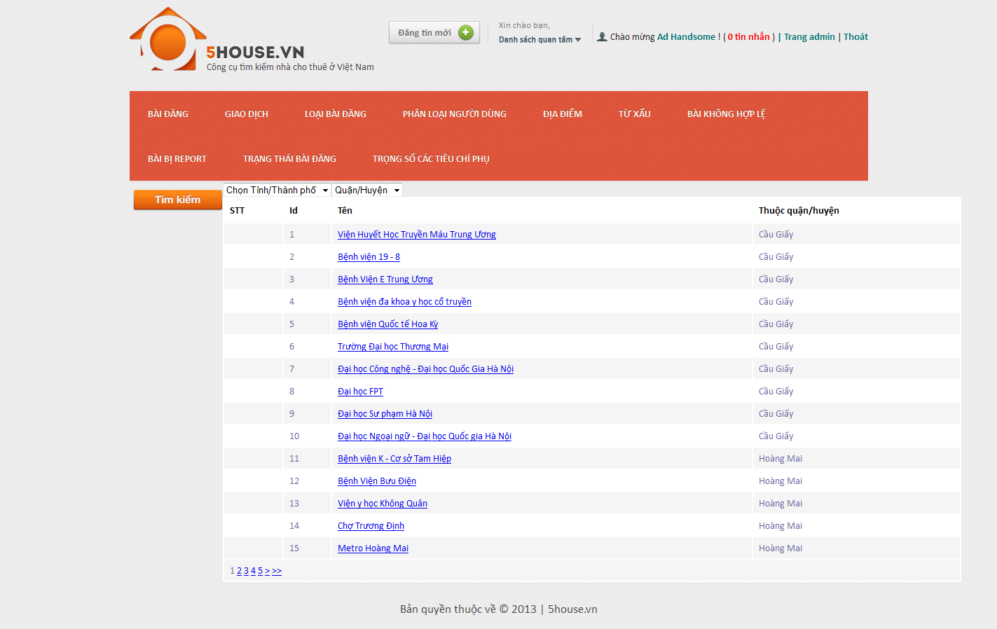

## Add new location

* + - * Login to the system as admin
      * Go to Admin Management page
      * Point on “Địa điểm”
      * Click on “Địa điểm phụ” tab
      * Click “Thêm mới” button

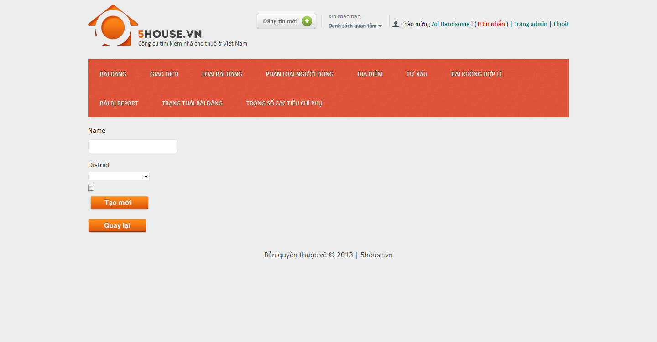

## Edit location

* + - * Login to the system as admin
      * Go to Admin Management page
      * Point on “Địa điểm”
      * Click on “Địa điểm phụ” tab
      * Click on an item on the table
      * Modify details
      * Click on “Lưu thay đổi” button
      * 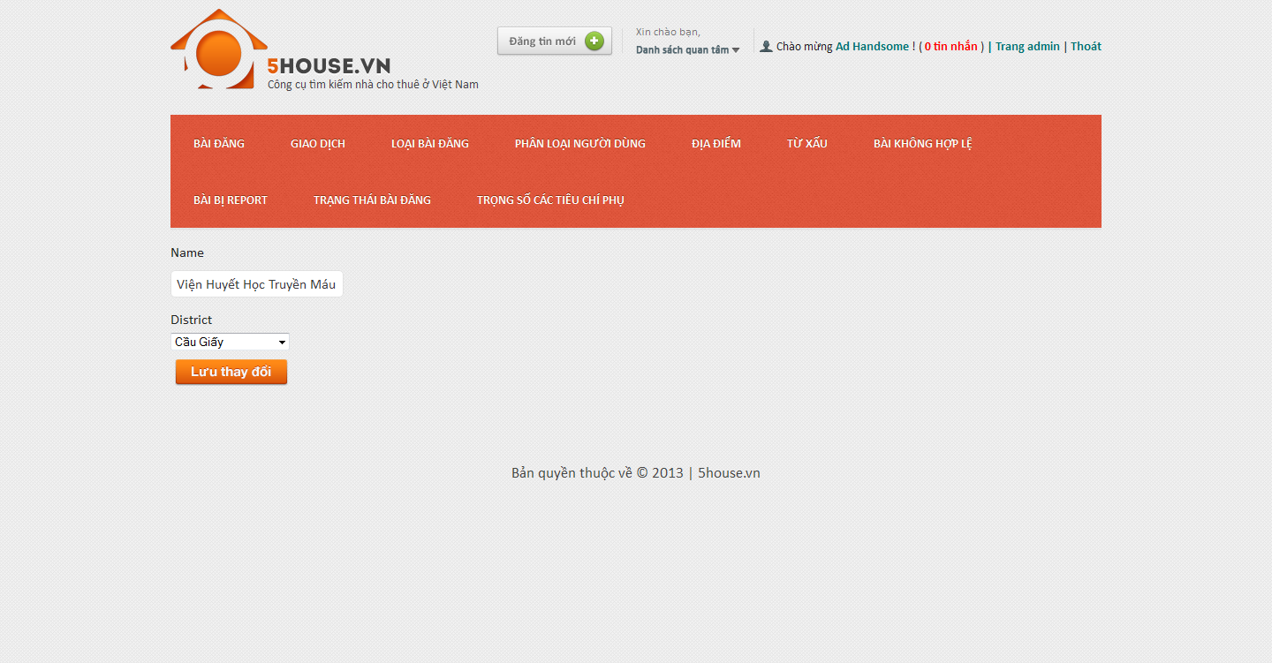

## Manage bad words

## View bad words list

* + - * Login to the system as admin
      * Go to Admin Management page
      * Point on “Từ xấu”
      * Click on “Từ xấu” tab
      * 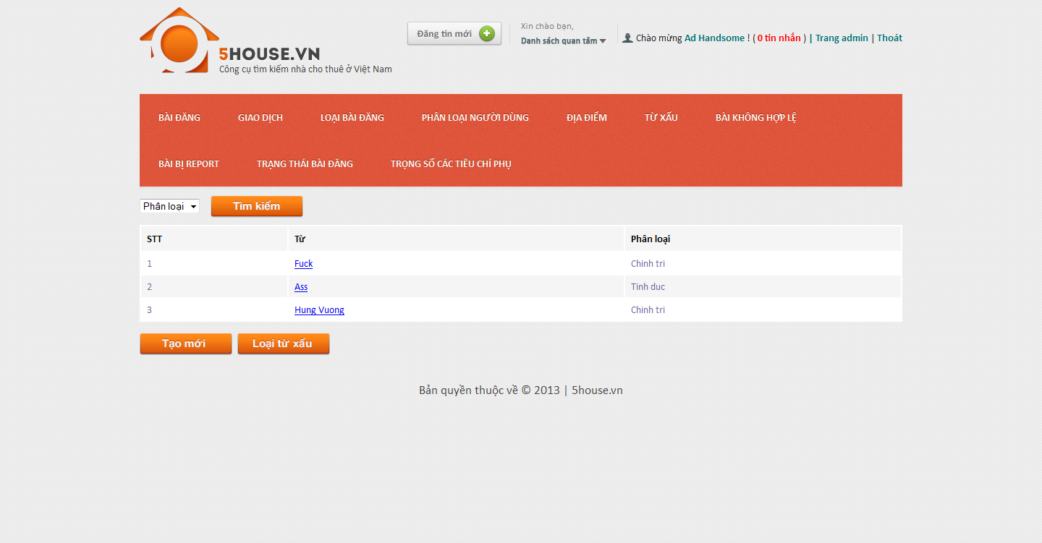

## Add new bad word

* + - * Login to the system as admin
      * Go to Admin Management page
      * Point on “Từ xấu”
      * Click on “Từ xấu” tab
      * Click “Tạo mới” button
      * Enter details as promted
      * Click “Tạo mới” button

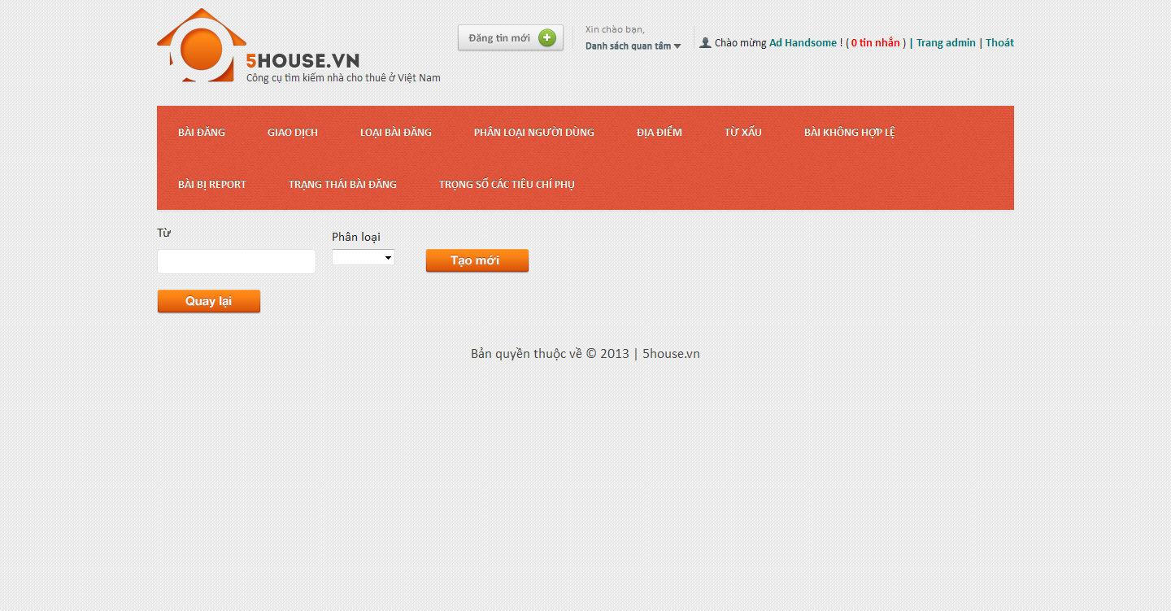

## Edit bad word

* + - * Login to the system as admin
      * Go to Admin Management page
      * Point on “Từ xấu”
      * Click on “Từ xấu” tab
      * Click on an item on the table
      * Modify details
      * Click on “Lưu thay đổi” button

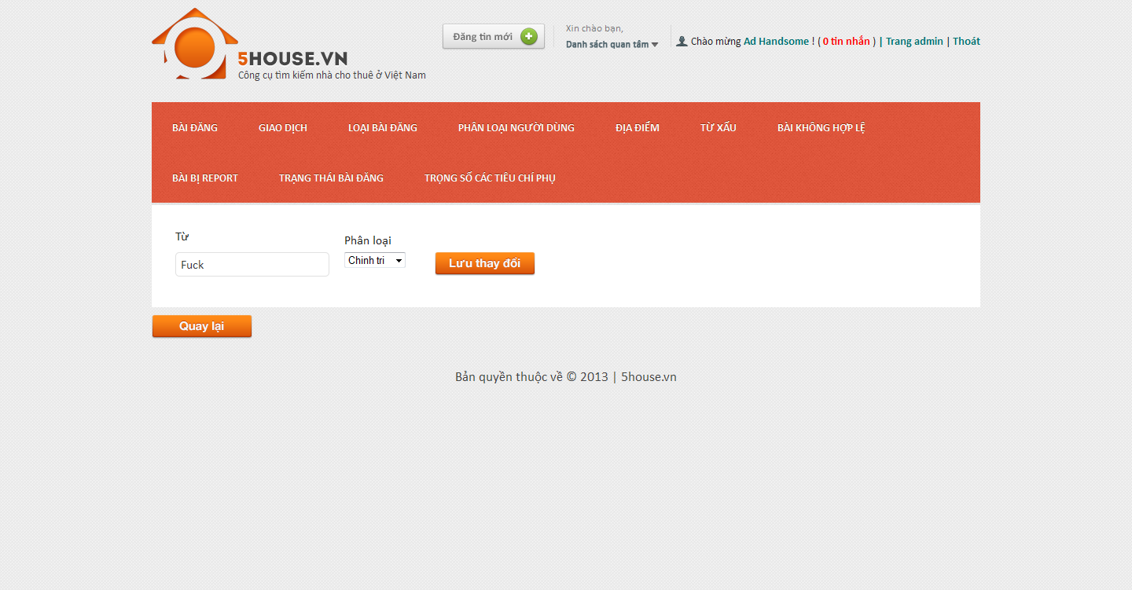

## Manage bad word categories

## View bad word categories list

* + - * Login to the system as admin
      * Go to Admin Management page
      * Point on “Từ xấu”
      * Click on “Phân loại từ xấu” tab

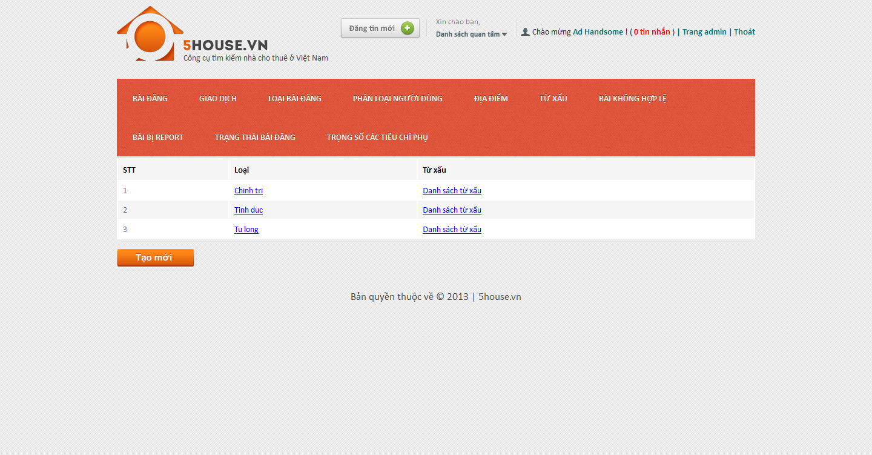

## Add new bad word category

* + - * Login to the system as admin
      * Go to Admin Management page
      * Point on “Từ xấu”
      * Click on “Phân loại từ xấu” tab
      * Click “Tạo mới” button
      * Enter details as promted
      * Click “Tạo mới” button

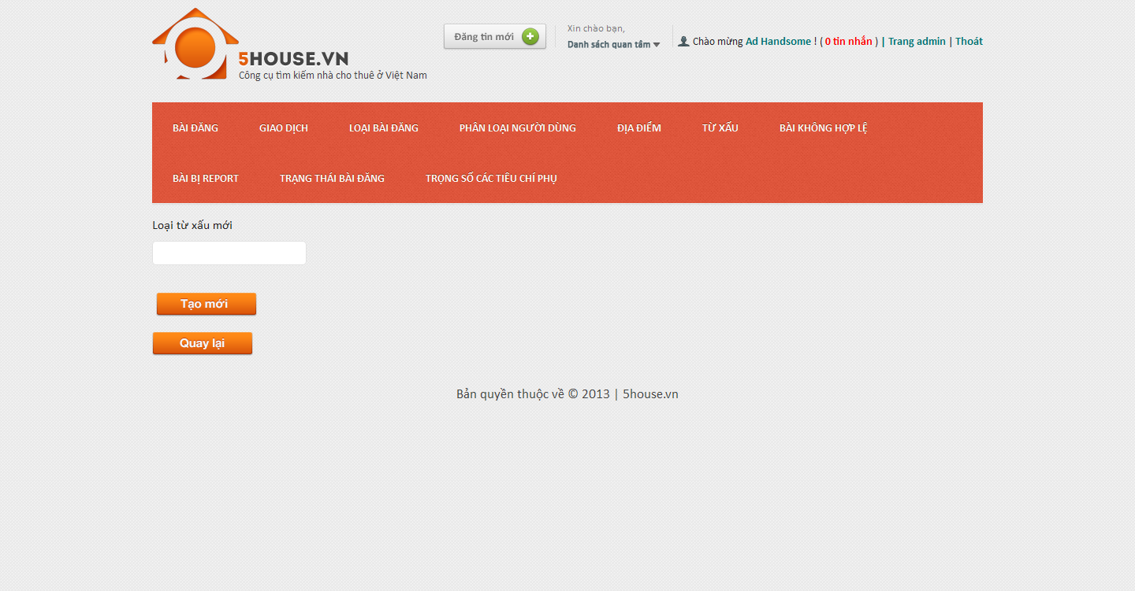

## Edit bad word category

* + - * Login to the system as admin
      * Go to Admin Management page
      * Point on “Từ xấu”
      * Click on “Phân loại từ xấu” tab
      * Click on an item on the table
      * Modify details
      * Click on “Lưu thay đổi” button

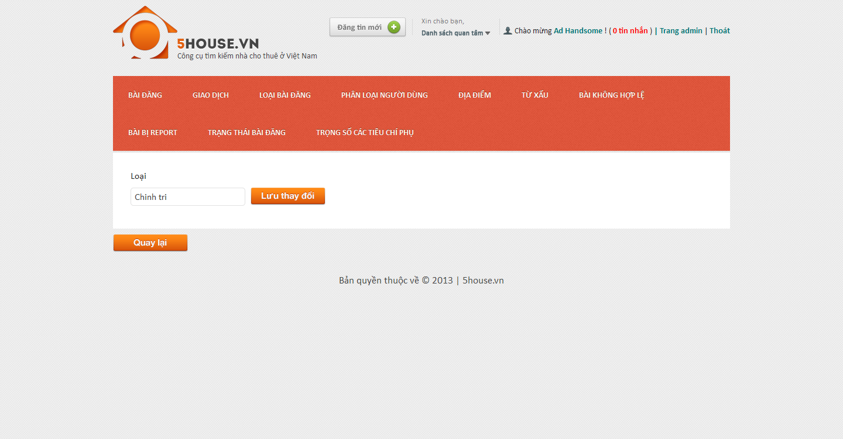

## Manage bad posts

* + - * Login to the system as admin
      * Go to Admin Management page
      * Click on “Bài không hợp lệ” tab
    - 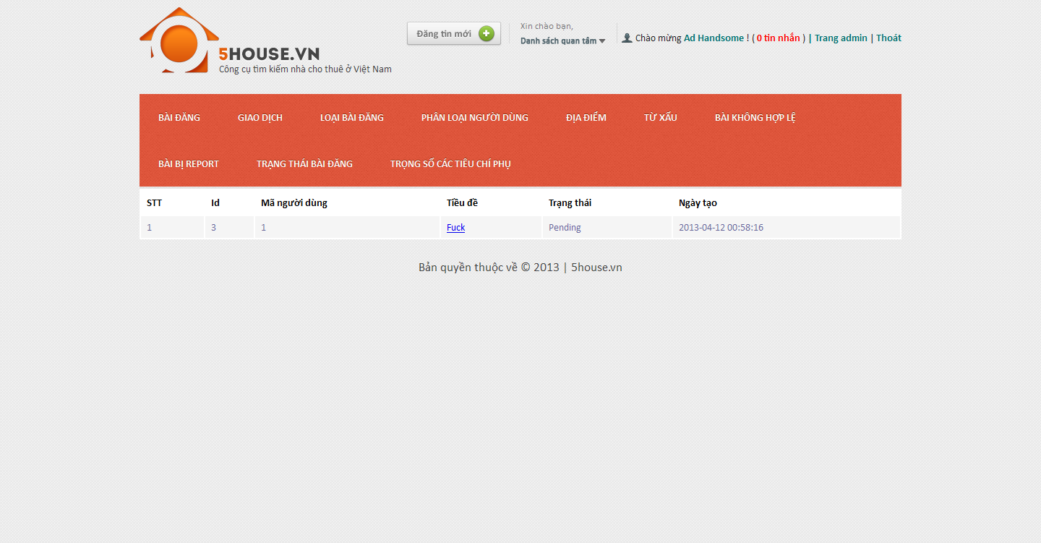

## Manage reported posts

* + - * Login to the system as admin
      * Go to Admin Management page
      * Click on “Bài bị report” tab
    - 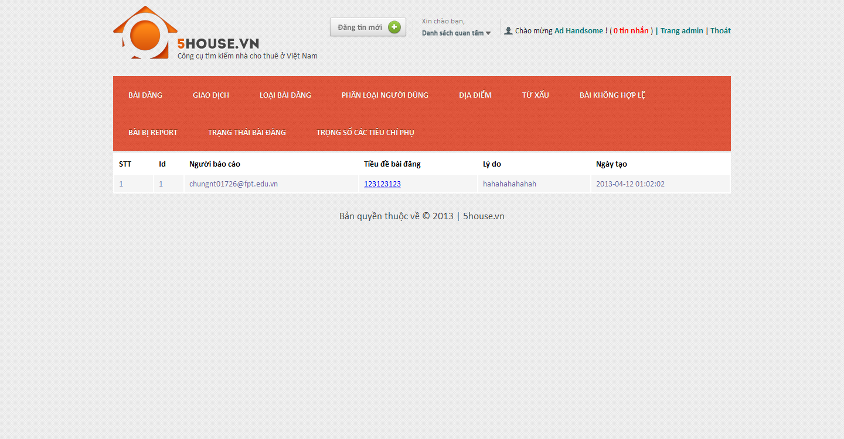

## Manage post statuses

## View post statuses list

* + - * Login to the system as admin
      * Go to Admin Management page
      * Click on “Trạng thái bài đăng” tab
      * 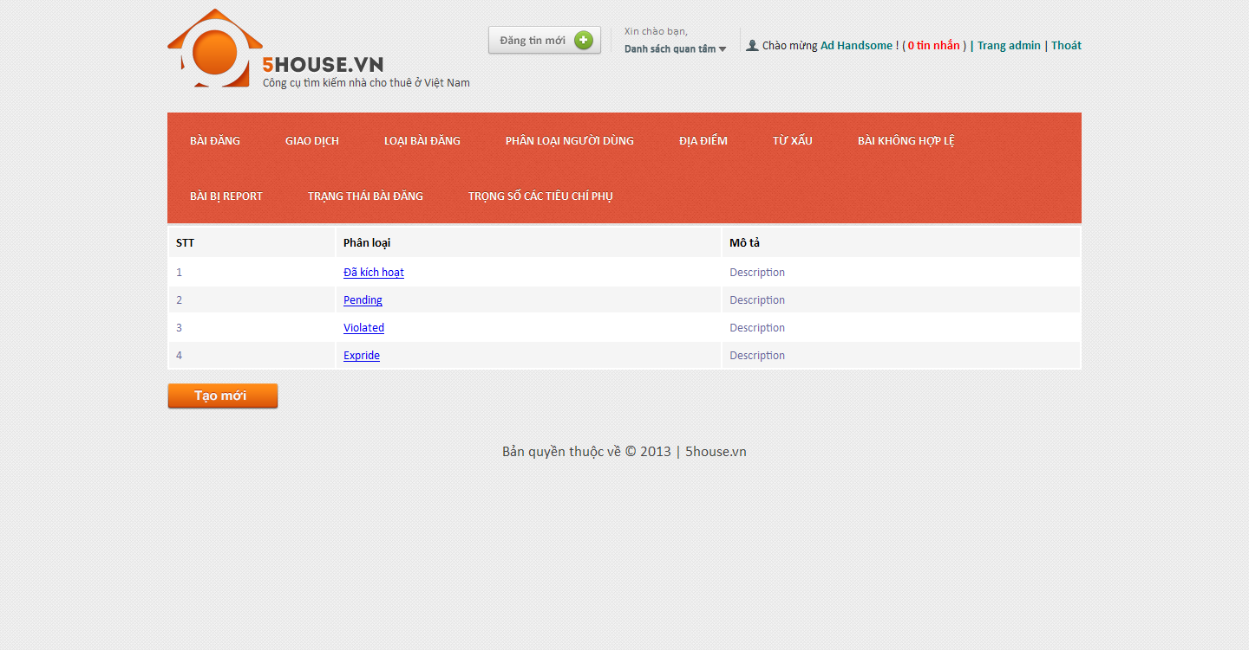

## Add new post status

* + - * Login to the system as admin
      * Go to Admin Management page
      * Click on “Trạng thái bài đăng” tab
      * Click “Tạo mới” button
      * Enter details as promted
      * Click “Tạo mới” button
      * 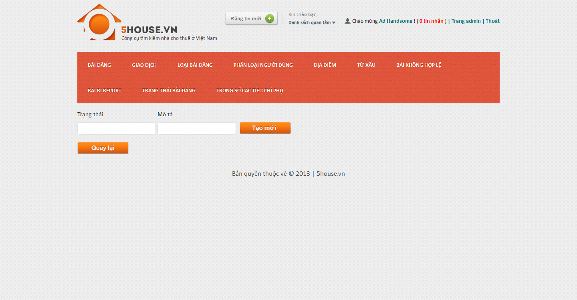

## Edit post status

* + - * Login to the system as admin
      * Go to Admin Management page
      * Click on “Trạng thái bài đăng” tab
      * Click on an item on the table
      * Modify details
      * Click on “Lưu thay đổi” button
      * 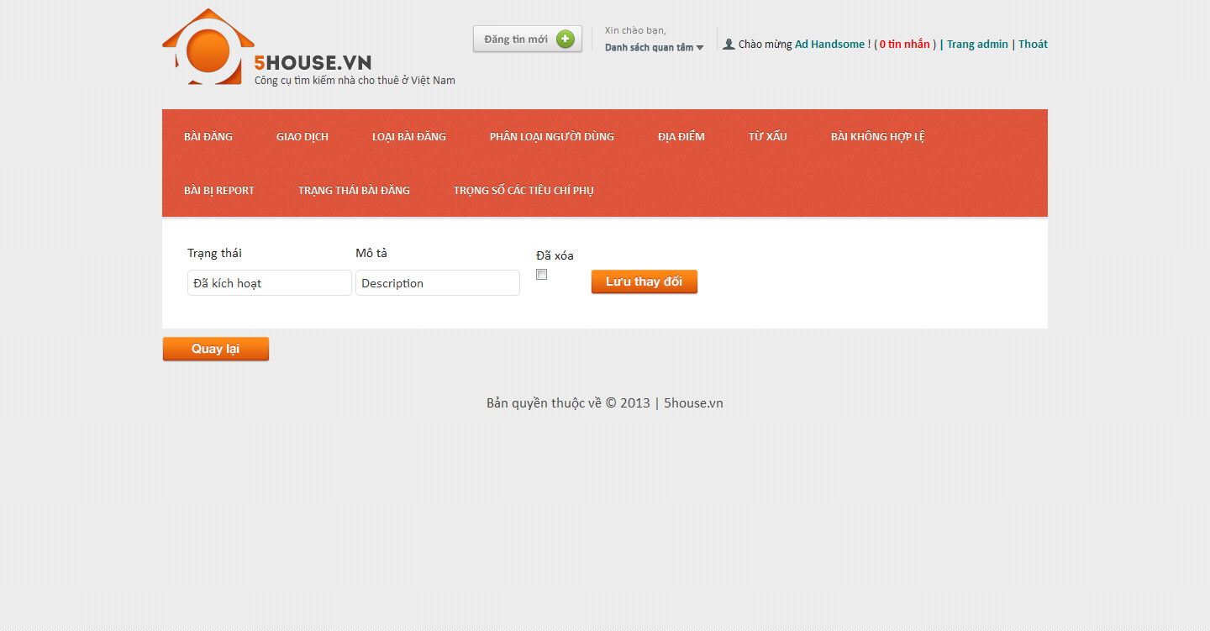

## Manage config score

## View score list

* + - * Login to the system as admin
      * Go to Admin Management page
      * Click on “Trọng số các tiêu chí phụ” tab

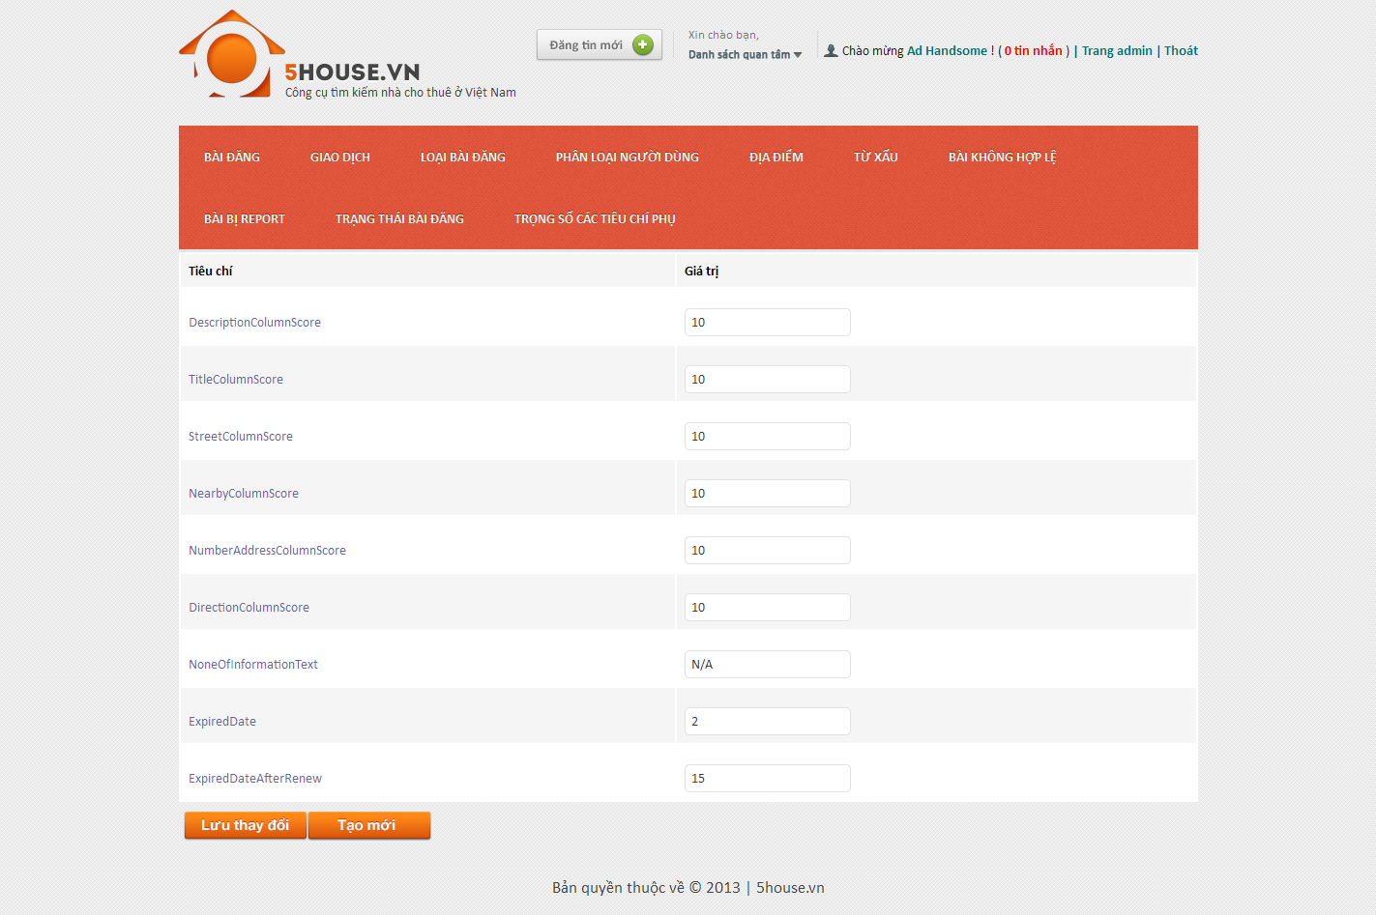

## Edit score value

* + - * Login to the system as admin
      * Go to Admin Management page
      * Click on “Trọng số các tiêu chí phụ” tab
      * Modify values
      * Click on “Lưu thay đổi” button



## Add new score

* + - * Login to the system as admin
      * Go to Admin Management page
      * Click on “Trọng số các tiêu chí phụ” tab
      * Click “Tạo mới” button
      * Enter details as promted
      * Click “Tạo mới” button

